
FERNTREE GULLY COMBINED PROBUS CLUB
October Newsletter

Ferntree Gully Combined Probus Club
Management Committee
Judy Bell President
M: 0458 480 918

Lorraine Baker Treasurer
M: 0423 243 689
Audrey Halls Newsletter/Website Officer

Joan Carroll General Committee
Valerie Thomas Morning Tea
Ross Baker General Committee

Linda Chan General Committee

Positions still to be filled: Membership Officer Outings & Activities Officer Trips & Tours Officer Publicity Officer
Welfare Officer Secretary
Vice President
was formed after an interest meeting held at the Coonara Community House on 18/09/2025.

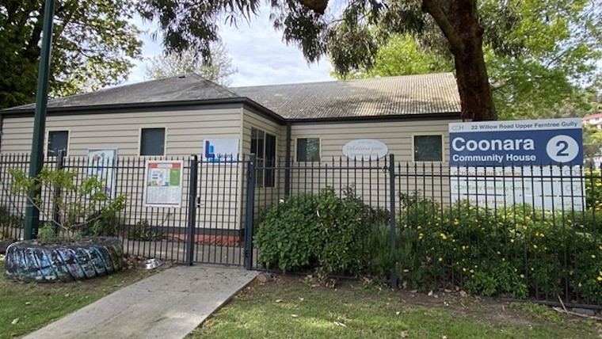
President’s Message:

Hello and a very warm welcome to you, our foundation members, and to our guests who I hope will join us in this exciting new venture.
I, with all the foundation committee members, am looking forward to making Ferntree Gully Combined Probus Club a highlight in our local community.
Our next meeting on 16 October will be an informal event. We want to give members and guests the opportunity to begin to get to know one another. Also to begin the conversations needed to gather what events and activities, you, the members want to see happening at this club.
We need to record the attendance of all members and guests for insurance purposes, so please aim to arrive from 9:30 am. The meeting will start promptly at 10am.
It is certainly a very exciting time being involved in the formation of a new Probus club.
I am really looking forward to seeing and meeting new members at our inaugural gathering on 10am at the Coonara Community House.
See you there!
Judy Bell (Foundation President)
OUR HOME BASE!

Meeting day/time: 3rd Thursday of every month at 10:00am
Meeting venue: Coonara Community House
Venue address: 22 Willow Road, Upper Ferntree Gully VIC 3156

Entry to the meeting room is through the gates at the rear carpark.


Quote of the day

Optimists are wrong as often as pessimists, but they have a lot more fun!!

Club Activities

The answers members have given as their interests, reveal that there are already a number of interests that members have in common.

The most popular interests are Exercise/ Walking, Gardening, and Table Games. Other interests include Dancing, Sports, Travel, Crafts and Dining Out, to name a few.
We think this is a great start for members to consider the formation of interest groups within the Ferntree Gully Probus Club.
We are seeking interest on a Christmas theme for the morning tea after our 20th of November meeting. Alternatively, whether others can assist in organizing a Christmas celebration venue for the club.

FIND FERNTREE GULLY
PROBUS ON SOCIAL MEDIA

FERNTREE GULLY COMBINED PROBUS
CLUB has a Facebook Group for Members at
www.facebook.comgroups/1512095003146316
FIND FERNTREE GULLY PROBUS ON THE WEB

www.probussouthpacific.org/microsites/ferntreegully

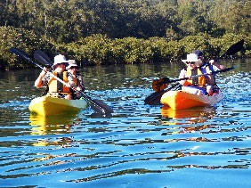
We’re all part of the Probus Community Now let’s get started having fun
with some exciting activities.
Next meeting dates/times: 16/10/2025, 10:00am
20/11/2025, 10:00am

Meeting day/time: 3rd Thursday of every month at 10:00am
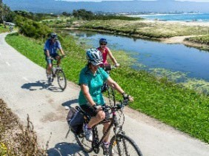
Meeting venue: Coonara Community House
Venue address: 22 Willow Road, Upper Ferntree Gully VIC 3156
Entry to the meeting room is through the gates at the rear carpark.

