



PROBUS Quotus

The Monthly Newsletter of:
The Probus Club of CARSELDINE Inc.

Ron Gough
0439 466 329
rongough39@gmail.com

SECRETARY
Lorelle Pacello
(For APOLOGIES when unable to attend a Meeting)
Phone 0435 094 049 ljpacello@yahoo.co.uk

MEMBERSHIP OFFICER
Linda Bracken
0400 071 436
Linda.bracken@bigpond.com

CARE AND CONCERN
Bev. Culverhouse
0429 045 268
Bevculver9@hotmail.com

MEETINGS
First Tuesday in the month (Except Nov.) at 9.45 am
Hornets AFL Club,
50 Graham Road,
Carseldine 4034
EDITORIAL
Sandy Handfield
Phone 3263 8487
Mobile 042 2496 673
sandrahandfield@gmail.com

PAYMENTS
Our Treasurer appreciates payments by EFT to CBA Account:-
BSB 064-151 AC 0090 3803
With a confirming email to michael.handfield@gmail.com

No.425 NOVEMBER 2025

…
Carseldine Club Calendar

The Carseldine Probus Club Meetings are held
at Hornets AFL Club, Graham Road, 4034 at 09:45 on the first Tuesday of each month

Because of Melbourne Cup Day on 4th November, we will be having our November Meeting a week later on 11th November

11th November 2025 - Tuesday
9:45 General Meeting.
Admission $5 Members - $7 Visitors

LYN - Our Guest Speaker Organiser,
reports that KEVIN HALLis now unable to be Guest Speaker for 11th NOVEMBER.and will be replaced by President Ron reporting on the recent Tasmanian Trip . Page 4

MEET A MEMBER: - Peter Jennings
Dates for your Diary: page 3

There and Back Walk Tuesday 25th November

Special Morning Tea at our last Probus
Meeting of 2025.

PROBUS CHRISTMAS PARTY 17TH NOVEMBER
11.30 FOR 12.00 NOON
$55.
Can pay by EFT see payments - left, or on our
Meeting Day – 11th November. 25

THE PROBUS CLUB of CARSELDINE, much appreciates the time and effort Bart Mellish
and Staff put into Printing extra copies of our Probus Quotus for our Carseldine Club. .

Presidents Report for November 2025
Dear Probians,
Welcome to our November edition of Quotus.
Well, I am back from Tasmania along with the other happy travellers. And what a great time we had. We went to all the major towns and their attractions. We considered the sad convict history of Tasmania and sailed up the Gordon River into the wilderness area. We saw wildlife: no not the Thylacines, but fairy penguins, echidnas, platypus, sea horses etc. We also spotted a few wild wombats and macropods. There were some belly laughs at Strahan when we took part in an interactive play about convicts who lived on Sarah Island building a boat, stealing it and escaping to Chile. We went to The Irish pub, and on Sunday we were all up singing and dancing with karaoke. Was it windy, rainy and chilly down there? You bet! I wore fleecy underwear, pullover, jacket, gloves, scarf and beanie just about every day.
A big thank you to Wendy for all her hard work in organising everything and watching out for us at every step of the way. We had a great bus driver: Peter, and a big thank you to treasurer Michael for endless work on his part.
I am already looking forward to our next holiday. It’s not so much where we go: it’s all about the company. If you want to consolidate your friendship with Probus members, this is the way to do it. Join us on a holiday.
Four wonderful people on this trip have decided to become members! We will make sure they get forms at our November meeting and can then be signed up in December.
Our committee is looking very strong now. Several recent members have agreed to help. Enda is learning the secretarial ropes for next year. Marilyn is our minutes secretary. Kerry is our new vice president (president for next year) and Lenore is also joining us.
Take care everyone. Let’s continue the year with lots of fun and friendship.
Best Regards
President Ron Gough
It is with regret we have to advise that Foundation and Life Member Marjorie Hillier passed away 1:00 a.m. on the 1st November. Rest in Peace, Marjorie.
Further information will be passed on when available

BIRTHDAYS and ANNIVERSARIES - NOVEMBER 2025

November | 14 | FRASER Ulsula
 | 16 | CULVERHOUSE Bev
 | 18 | HOOPER Dawn
 | 27 | JONES Elizabeth

DATES FOR YOUR DIARY

All programmes are flexible and open to change. Check with coordinators please.
Please advise if changes need to be made to this program.

LORELLE
SEE the sheet at the meeting on table near back door - Email : ljpacello@yahoo.co.uk FOR SIGNING UP

I have 3 places left for Annie at the Lyric Theatre Wednesday 21 January 1.00pm Cost $75. Sign-up
LORELLE has booked for the play, THE GREAT GATSBY at THE PLAYHOUSE WED. 04.03.26 AT
1.00PM.$89. ONLY TWO PLACES LEFT – PLEASE EMAIL LORELLE, IF INTERESTED..

C A T S To: All Members

I received the following information about Cats today. This is performing for 2 weeks only in February.
The cost is $69.90 Concession (Pension and seniors cards)
Exspressions of interest to me asap please. Priority Presale Access started a while ago now..
……………………………………………………………………………………………………………………..

OUR ‘THERE AND BACK WALK’ will be Meeting at: DAVIS PARK AT 10.00AM FOR
LAST TUESDAY OF NOVEMBER- 25TH

Sadly, only two arrived to walk for our last ‘There and back walk’– I do not think that has happened before,
So sorry, Anna & John.

ARMCHAIR TRAVELLERS 12.30pm – 2.30pm

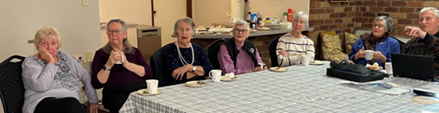

– Judy Thompson’s home – the LAST THUSDAY of March, July and October.2026

Just bring your lunch – or lunch to share
Why not come along and see if you enjoy the afternoon?

LAST MONTH’S SPEAKER Richard Kinnon

Please click HERE (below) for any MORE information you need.
We all enjoyed Richard Kinnon’s presentation, our last Guest Speaker, 07/10/2025
Richard was very enthusiastic, sharing his interesting experiences and stories with us, .
Please click HERE to view Richard’s bio and download promotional materials for you to read and enjoy..
We are sure if you would like to get in touch with Richard, he would be thrilled to help you.

GUEST SPEAKER FOR NOVEMBER

Lyn regrets that KEVIN HALL will be unable to speak to us about Crystal methamphetamine drug use, at our next meeting..

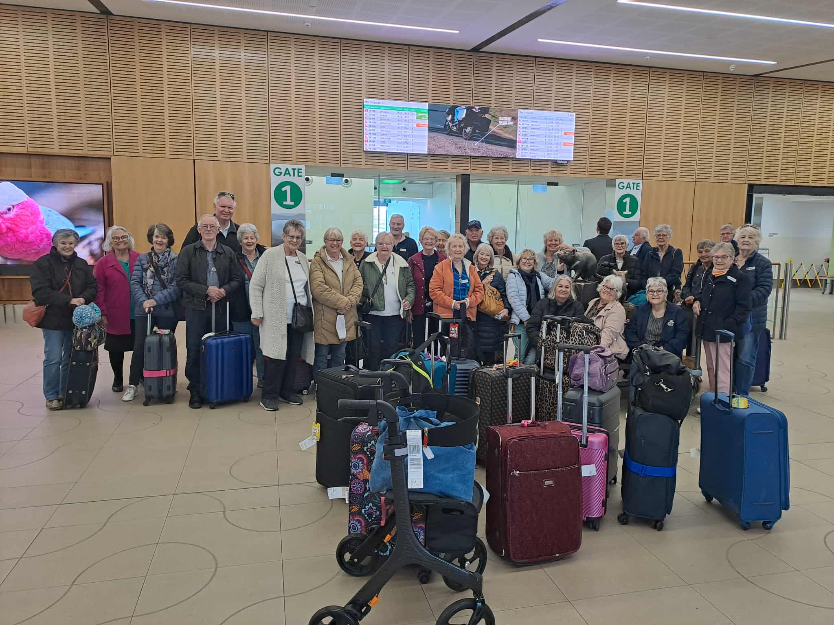

President Ron is stepping up at short notice to report on the recent Tasmanian Trip, assisted by John O’brian who provided this photo of the Tasmanian travelers arriving at Hobart Airport. John kindly shared his photos with Ron, and many others, to enhance their Story.

Please note John’s description of the Trip will be attached to the email with this P.Q.

John has been very generous in sharing his photos with many Friends in Probus to enhance their Tassie Story.

Meet a New Member in October

Dear Probians, Sandy here.. I feel I need to say just a little about Enda before you read his Biography. We have had to cut it down quite considerably the length, as we have never had Probians, quite as energetic as Linda and Enda, and I am sure as time goes by, we will enjoy hearing more about this Couple’s extraordinary energy and Lives.
Enda surprised me at Choir a few weeks ago but I did not think it could be Enda so did not say hello! Just a few weeks ago, Edna knew me by name at choir, so confirmed it was indeed Edna! He might just pop up anywhere, any time, so do say hello! Enjoy Enda’s shortened Story...
Enda Bracken's Biography

Enda was born in Clara, County Offaly, Ireland in 1948 but spent his first 4 years in Totternhoe, next to Whipsnade Zoo west of Luton. We migrated to Oxley, Brisbane in 1952 and then to 14 Beaudesert Road Moorooka. He went to school at Yeronga State Primary and State High Schools.
At 15 years old he left school to work at the Repatriation Department, dealing on the counter and the filing system with veterans of WW1, WW2 and Korean Wars as well as Borneo- Malaya Intervention - while studying for his Senior at night classes held in the Old Trocadero Dance Hall.
He gained a Teacher’s Scholarship in 1966, emerging in 1968 to teach at Moorooka State School for 8 months.
He then taught at Newstead Opportunity School, Windsor Opportunity School, Ayr Opportunity School, Inala Opportunity School, Opening Biloela Opportunity Classes, Caboolture Opportunity Classes
Then as Principal opening Kuraby Special School, then Nambour Special School, Mt. Isa Special School, Baroona Special School and finally Dutton Park Special School. .
. . . . After which he became Principal of Bulimba Primary School followed by 8 years at Childers Primary School (including during the Backpackers’ Fire). He then retired.
He has served on Apex and Rotary Clubs, Marriage Guidance Council and a Welfare Council.
Enda and Linda then embarked on cheap overseas touring, beginning with the British Isles and Western-Southern Europe; Israel-Jordan-Egypt; South America, Southern Spain; Greece and Turkey; Great Britain-Ireland 2008.
From 2009 – in a Hi-Ace campervan - spent10 years, travelling over all of Australia including circumnavigating the continent as well as exploring each State separately.
They then travelled to the Balkans, Russia, Baltic States, Poland and Czechoslovakia then Thailand, Laos, Cambodia and Vietnam. They will be going to India-Sri Lanka in 14–28 October 2025.
Enda’s pleasures are – jogging, home gym and bush-walking - culturally he loves classical music, history, religion and documentaries. Our children have scattered interstate and overseas, with one coming back to live in Bracken Ridge.

 | Programme of Activities 2025 version 16
Event | Includes | Location | Co Ordinator | Dates
Meetings / Guest Sp | Morning tea | Hornets | Lyn / Club services | 1st Tues ea. month (inc Jan)
Trips | Morning Tea / lunch | TBA | Wendy | 3rd Tues most months
 | 18/2 18/3 20/5 17/6 15/7 19/8 16/9 23\9
There and Back Walk | Morning Tea/ Lunch | Arthur Davis 10.00am 30\09 Park | Ron Lorelle | 4th Tues 10 for 10:30
Australia Day Picnic | Picnic BBQ/ Lunch | Arthur Davis Park ?? | club services | Tuesday 21st January
Budget meeting | Morning tea | Judy's place | Joan Dwight Ron Alan | January 15th 1:30
Ten Pin Bowling | Afternoon tea | Aspley Bowl | Lorelle | Thurs 27 /2 at 1 for 1:30pm
 |  |  |  | and 24/4 26/6 23/10
Shopping Centre Stall | Morning tea | Hypermarket | Ron | 20/2 20/3 17/4 10-12am
Arm Chair Travel | bring lunch to share | Judy's place | Lorelle | 27/3 24/7 30/10 12:30-2:30
Trivia at Hornets | Morning Tea | Hornets | Alan and Joan | Tuesday 1st July
Maritime Mus walk | Lunch | South Bank | Ron/ Lorelle | Sunday 20/7 9:15
Birthday lunch | Lunch | Hornets | Norma / Lyn Bev | Tuesday 15th April
Away Trip |  | Tasmania | Wendy | October 10-21st
Trivia at Geebung | Morning Tea | Geebung RSL | Lyn | Monday 2nd June
Car Event | Club / PubLunch | TBA | Ron Peter Lorelle | Tuesday 19th August
Probus Day | Morning Tea | Hornets | Ron | Tuesday 7th Oct
Planning Day | Morning tea | TBA | Ron | Thurs Nov 6th
Melbourne Cup | Lunch | Hornets | Ron / Hornets | Tues 4th November
Christmas Party | Lunch | Hornets | Club services / Bev/Lyn | Mon 17th Nov 11:30
Xmas morning tea | Morning Tea | Hornets | club services | Tuesday 2nd Dec

All programmes are flexible and open to change. Check with coordinators please.
Please advise if changes need to be made to this program.

