PROBING THE  BRIDGE  January 2026  Private and confidential for Probus use only |  |  |   Combined Probus Club of Northbridge Inc  PO Box 233  Northbridge, NSW 1560
President  Bev Piper  0413 742 846  Vice-President  Gordon Kenny  0439 013 616  Secretary  Heather Skeen  0412 611 399  Treasurer  Dick Watson  0431 160 587  Membership  Judy Smith  0422 537 044  Past President  Peter McNair  0415 242 628  Community Liaison  Ros Kenny  0439 430 726  Travel  Carol Jones  0437 494 667  Activities  Marlene Black  0480 264 237  Theatre  Dawn Spinks  0410 313 084  Newsletter  Penny Lye  9958 7566  0411 988 630  Speakers  Malcolm Lye  0449 191 246  Welfare  Kerrie Williams  0407 914 699  Catering  Jan Loiterton  0407 732 255  Public Officer  Roger Williams  0422 882 306 | From the President  As we step into 2026, it’s hard to believe how swiftly 2025 has passed us by. Time seems to fly even faster as we reach our senior years, and the past year was no exception. On New Year’s Eve, I was fortunate to welcome the new year from a friend’s rooftop. We were treated to a spectacular view of the city, including the Opera House, harbour and Harbour Bridge. Despite a touch of rain, the weather held off just enough to allow us to fully enjoy the breathtaking fireworks and festivities, making it a truly memorable start to the year.  Since the Probus Christmas lunch on December 1, we have enjoyed a substantial break. This period has provided a wonderful chance for members to reconnect with family and friends, embracing the spirit of Christmas. The opportunity to gather with loved ones and share in the festive season has been valued by many, allowing for relaxation and meaningful catch-up.  A heartfelt thank you goes to Marlene, who did a fantastic job organising a memorable lunch. Our Club subsidised a drink for everyone, and there was a range of prizes up for grabs, adding to the festive atmosphere. Pat provided an entertaining and challenging Christmas quiz, which was a real highlight for many. It is amazing how much knowledge we have managed to retain. Paulette delighted us with her unique Christmas show, and Kerrie brought everyone together by accompanying us on the keyboard while we sang Christmas carols. We are truly fortunate to have such a wealth of talent and enthusiasm among our members.  Thank you to each and every one of you for your enthusiastic participation which made the event such a success. While some Probus Clubs are facing declining membership, we are grateful that Northbridge continues to thrive. To maintain our high standards, it is important for us to continue promoting our Club, highlighting the many benefits of membership, and encouraging participation in both activities and Committee roles. This January newsletter will keep you informed about the activities already organised to kick off 2026.  January meeting presents author Sue Williams as our guest speaker. Sue will share her expertise on the citizens of colonial Australia, a topic particularly relevant given the timing of our gathering. A reminder that our meeting is scheduled to take place immediately after Australia Day, at 10am on Tuesday, January 27.  Let us raise a toast to a wonderful 2026. May the coming year be filled with good health, happiness, and memorable moments for all our members. Together, we can look forward to making the most of every occasion and continuing to foster the spirit of friendship and community within our Club.  President Bev  Our next meeting will be held at Northbridge Golf Club on Tuesday, January 27. starting at 10am sharp. If you can’t attend, please phone or text Judy Smith  0422 537 044 before the meeting. Alison Coleman will be the five-minute speaker.  Note that the meeting is on Tuesday, because Monday is Australia Day. The following meeting will be held on February 16.

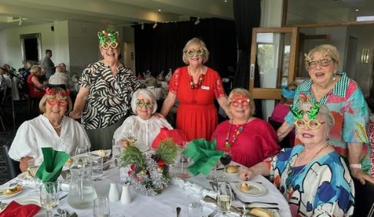
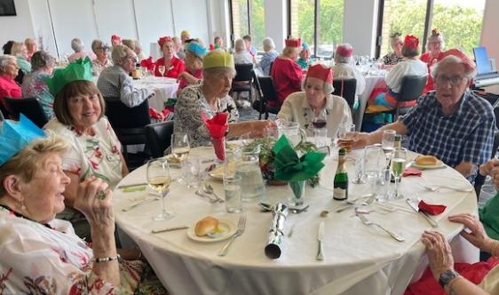
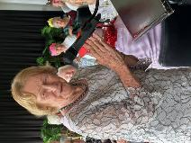
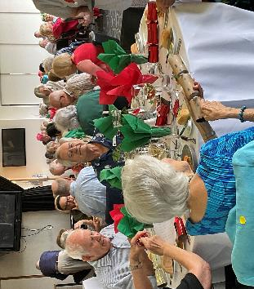
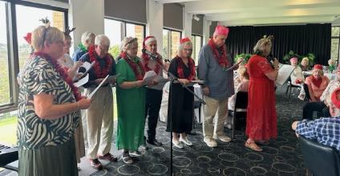
Thanks to Heather Skeen, Tuyet Drummond and Malcolm Lye for photos.
Happy snaps from our
Christmas lunch
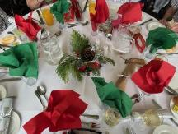

Dates for your 2026 diary
We encourage members to pay for outings online to Probus Tours Account, BSB 062 215, A/C 10073196, please. Don’t forget to register at the desk that you will be attending, as well as identifying yourself with your online payment.

Thursday, January 29, 2026
Infuzions Restaurant, Cammeray, 12 noon
Payment of $50 to be made at the January meeting.

Monday, February 2
Coffee catchup, 2.30pm
Join an informal gathering of members for coffee and a chat at Inner Cravings, at Northbridge Plaza. No need to book, just turn up. Hosted by Kerrie Williams.

Friday, February 20
Tour of Queen Victoria Building, $25
We’ll meet at 10.45am at the information desk on the ground floor of the Queen Victoria Building. The tour starts at 11am. After the tour, we will go by Light Rail to Circular Quay for lunch at the cafe on the ground floor of the Museum of Contemporary Art (own expense). Numbers and payment at the January or February meetings.

Tuesday, February 24
Just Lunch, 12 noon at North Sydney Hotel,
292 Miller St (opposite North Sydney Oval)
Order your own drinks and meals at the bar.
Add your name to the list so we can ensure you have a seat at our booked tables.

Thursday, February 26
$2.50 Club outing to Bronte Beach
We will meet at the foot of the Town Hall steps at 11am and catch a train to Bondi Junction, then a bus to Bronte Beach where we will have lunch at a choice of eateries. After lunch, there will be a short optional stroll to the beachfront before catching the bus to Bondi Junction, train to Town Hall station, then Metro from nearby Gadigal station to Victoria Cross station, opposite the North Sydney Council Chambers, for the journey home.

Thursday, March 19
Trip to Wiseman’s Ferry. Details TBA.

Wednesday, April 22
Anastasia, Sydney Lyric Theatre, 1pm
This event is fully booked. Payment is now due and payable either by cash at the January meeting or by direct transfer into Probus Tours Account.

October 31-November 10
Probus 50th anniversary cruise with Trade Travel
Visiting Hobart, Kangaroo Island (Penneshaw), Adelaide, Melbourne, Eden, Sydney on the Celebrity Solstice. Only balcony rooms available: single $7600 per person, share $8650. Drinks and wi-fi not included. Ten single rooms and three shared rooms are being held for our club until Monday, February 8.

+
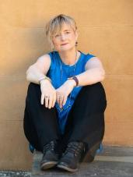
Coming guest speakers
Our speaker in January will be Sue Williams (pictured right), a best-selling author and award-winning journalist and travel writer. She is a masterful writer of historical fiction. She will be speaking on the subject “Power, passion and pride”, highlighting her Australian series of novels which are mainly about the Macarthur, Macquarie and Bligh families. Sue will have books available for sale after the meeting.
In February, our speaker will be Tom Sweeney AOM, a prominent figure in the Australian arts community. He is best known for his dedication to Willoughby Theatre Company, with which he has been involved for more than 50 years, serving as an actor, director, administrator and president. Tom will be talking about the theatre.
Susan Alexander will be speaking to the club in March about her book “A Spanish Love Affair”. Susan is a former tennis champion, successful businesswoman and a poet. Her book is a memoir of her time in Madrid, her experiences on the European tennis circuit and her marriage to a Spaniard. She will be selling copies of her book after the talk.
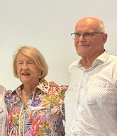
The results of marrying a good woman
Newly inducted member Harvey Ord tells his and Carole’s story.

As computer dating had not been invented and I could not sing a note I went to the Muswellbrook Musical Society. Carole made the first of her life changing decisions when she invited me to partner her to a ball. We have been together for over 50 years.

Carole worked in the bank, and I was principal of Muswellbrook St Heliers Prison School for convicted juveniles with the lowest IQ 120. For the previous 10 years I had combined teaching with building and acquired four houses in Sydney.

Returning to Sydney I became principal of Wairoa Special School at Bondi (IQs below 60). Carole had twins. Leaving teaching Carole and I went into full time building.

Carole would find blocks of land in the Shire or houses, at auction, to buy and rebuild whilst running the family. Every year we would build ourselves a new house, changing the furniture at her brother’s auction business. Carole inspected a house in Marana Road, Northbridge, that had been illegally converted to six flats. Six months later she spotted it in the Herald up for auction. We moved to Northbridge, our children went to Northbridge Public and I started building in the area.

Working in the Lord Nelson’s office, Carole won an award which led us to opening a Bed and Breakfast in our home. This increased to 11 rooms when I added a dual occupancy. With Willoughby Council closing us down we sold both houses and travelled for six months. During the taxi ride home to our son’s house Carole spotted the Vulcan Hotel in Ultimo up for auction. Her skill at forming relationships allowed us to buy before auction. Thirty years later we have developed it into a 4 Star boutique hotel with 46 en-suite rooms and a penthouse.

Joining Probus is another of her great decisions.
Harvey and Carole are pictured above at their induction in November 2025.

Tips to avoid trips and falls in the home
In the bathroom: use non-slip flooring; wipe up puddles promptly; install grab bars; have toiletries in easy reach in the shower; and consider a shower stool or chair.


In the kitchen: use a stool or ladder with handrails to reach high shelves; wear non-slip footwear; don’t have pet bowls or shopping bags on the floor; keep frequently used items within easy reach; and clean up spills immediately.

On the stairs: ensure they are well lit; keep them free from clutter; install handrails; replace any worn carpet; and use adhesive non-slip edging to aid visibility.

In the living areas: keep flooring in good condition; secure the rugs with non-slip underlay; remove any rugs with curled edges; keep the floor free from clutter; and don’t have electrical cords running across the floor.
Adapted from Anglicare’s magazine “Ageless”

Last but not least, don’t forget to bring for the book table any books you have
enjoyed over the holidays and would like to share with others. There will also be a selection of jigsaw puzzles.

