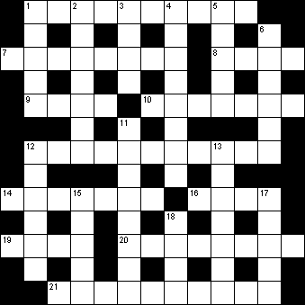
Across | Down
  1 |  | Petite iron designed for one with a suit (10)
  7 |  | Old song concerning an idler (8)
  8 |  | Get a poor number of spectators (4)
  9 |  | Herb in perfect condition (4)
  10 |  | Satisfied with what is inside (7)
  12 |  | Buchan's novel translation of Ten Large Men (11)
  14 |  | Childhood in the imagination? (7)
  16 |  | Settled partnership? (4)
  19 |  | Secured when not eating (4)
  20 |  | Let oboes become out of date (8)
  21 |  | Professional farm vehicle used by geometry students (10)
  1 |  | The prime minister entertains little Sarah with a song (5)
  2 |  | Aintree fixture for apprentice? (7)
  3 |  | Ancient city not completely destroyed? (4)
  4 |  | I plan too carelessly, but it's not mandatory (8)
  5 |  | The crew dined, we hear (5)
  6 |  | Weight carried by expert without delay (2,4)
  11 |  | Stunning sort of tournament? (8)
  12 |  | Pleasant Ealing production? (6)
  13 |  | One of three allowed on journey (7)
  15 |  | A flower can make you stare wildly (5)
  17 |  | Measuring device encountered by the queen (5)
  18 |  | The continent of China, Siam, etc. (4)

