**REDCLIFFE PENINSULA PROBUS CLUB INC**

Meets on the 4th Tuesday of each month

**August 2025**

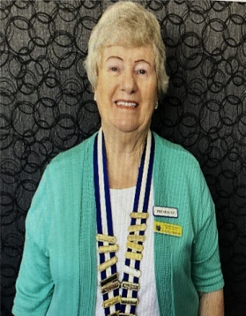Good day to everyone

Thank you for a very good response to my email about attendance. As our numbers have grown, it is very important that you always let me know if you are coming. There were 50 attendees and this has been our biggest number in five years.

Welcome to our two new visitors, Kim Thomas and Kerrie Sherred. It is great to see that you have already booked a tour. A fond farewell to Irene and we wish her a safe journey home to Canada.

Thanks to all of you and especially Barbara Smith for your participation in accepting the new Constitution and Standing Resolutions. The Standing Resolutions will probably need to be reviewed each year but we will cross that bridge when we come to it.

**Life Memberships**. Congratulations to Denis and Shirley Megaloconomos for being granted Life Membership with our club. You have both given the club many hours of volunteering and we greatly appreciate your efforts over the past ten years. Best wishes to both of you.

**Jumper/Blouse Competition**. It was great to see many people wearing bright tops for a bit of fun. Congratulations to Annette Pincham and Bruce Shipstone for winning the female and male prizes for the best outfit.

**Outdoor meeting**. We are planning to have our meeting outdoors in September. As yet the committee has not decided on a venue. We ask that you bring your own chair, hat and drinks along with a plate to share. This morning will not cost you your usual attendance fee. Generally we find this is always a very pleasant experience.

**Welfare**. Joy Turner is still continuing with her treatment. Trish Anderson is pleased to be rid of her plaster arm cast but is still experiencing some pain. We wish both Beryl and Martin speedy recoveries after their surgeries. Reg Smith is doing very well without any treatment.

**Guest Speaker**. At our August meeting, Sally Atkins will speak on archaeology in England.

**Five minutes of Fame**. We are starting a new segment where people speak about themselves or a hobby or an exciting event in their lives. Taboo subjects are politics, religion and your health. Beryl Curtis will be the first speaker in August. You cannot speak longer than ten minutes.

**Trip Report – 24 July 2025**

Our Christmas in July outing was an excellent day out. Prior to the lunch we enjoyed morning tea at Mt Tamborine before gathering at the Bernard Hotel in Mt Tambourine for our luncheon venue where we were served a wonderful three course meal. Some of the group took advantage of the sky walk and thoroughly enjoyed it. Thank you Trish and Lynette for your organization.

**Book Group** meets on the 1st Tuesday of the month between 2 & 4 pm at 5/1A Warde Street Scarborough

The library provides us with the sets of books that we have ordered earlier. The last book we read was ‘Horse’ by Geraldine Brooks and though none of us knew much about the history of horse racing or had much experience of horses, most of us enjoyed the book We are currently reading ‘Taking Tom Murray Home’ by Tim Slee. At the moment there are 8 of us and if anyone else is interested in coming we could welcome another 2 people ( this is maximum number of books in the library sets).Convenor Sally Atkins

**Birthdays in August**



Martin Atkins

Mike Hartley

Joy Turner

**Activities for August**

|  |  |  |  |
| --- | --- | --- | --- |
| **Activity** | **Location** | **Date/Time** | **Contact** |
| Canasta | Redcliffe Library | 4, 11, 18, 25 August at 9 am | Malcolm Gresham  0427497339 |
| Book Club | 5/1 Warde Street Scarborough | 5 August at 2.00pm | Sally Atkins  0451021832 |
| Lunch | The Ambassador Hotel, Marine Parade Redcliife | 12 August at 11.30 am ***  **\*\*\*Please advise Shirley either by email or phone no later than Friday 8 August so the reservation can be confirmed** | Shirley Megaloconomos 0408772622 |
| Overnight tour | Australian Outback Spectacular & Albert River River Winery | 13 and 14 August  **Note: This tour is fully booked** | Trish Seymour  0427240744 |
| Committee Meeting | 65 Centaur Street Clontarf | 19 August at 9.30 am | Gayle Mann |
| Club Meeting | Moreton Bay Boat Club | 26 August 9.15 am for 9.30 am | Gayle Mann |

**Forward notice of Activities for September**

|  |  |  |  |
| --- | --- | --- | --- |
| **Activity** | **Location** | **Date/Time** | **Contact** |
| Canasta | Redcliffe Library | 1, 8, 15, 22, 29 September – 9 am | Malcolm Gresham  0427497339 |
| Book Club | 5/1 Warde Street Scarborough | 2 September – 2 pm | Sally Atkins  0451021832 |
| Morning Tea | Sunny’s Sebel Hotel, Margate Pde, Margate, 10. | 9 September – 10 am | Shirley Megaloconomos 0408772622 |
| Mystery Tour – cost $68** | TBA | **Friday** 19 September | Trish Seymour  0427240744 |
| Committee Meeting | 65 Centaur Street Clontarf | 16 September – 9.30 am | Gayle Mann |
| Club Meeting | Venue to be advised | 23 September – 9.15 am for 9.30 am | Gayle Mann |

\*\***A note from Trish – the Mystery Tour is very popular and as we share with our sister Club our Club members names need to be registered promptly so please make sure you don’t miss out**

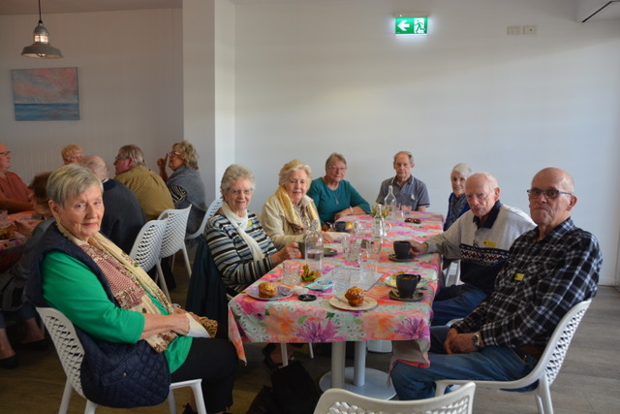Some of our members enjoying Morning tea at Jetty Lounge Redcliffe

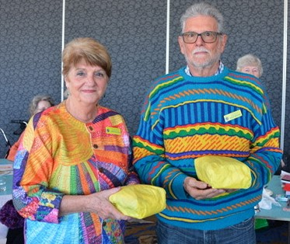Annette Pincham and Bruce Shipstone were the winners of the brightest outfit in our July meeting competition.

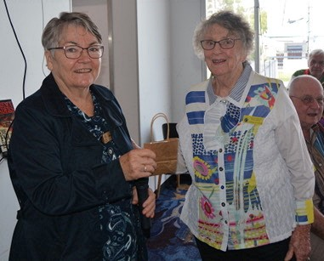

Our July guest speaker who spoke on Seniors Energy Savings, being presented with a gift by Ann Evans.

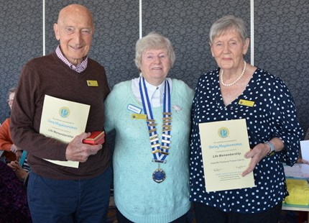

Denis and Shirley Megaloconomos being presented with Life Membership by our president Gayle Mann.

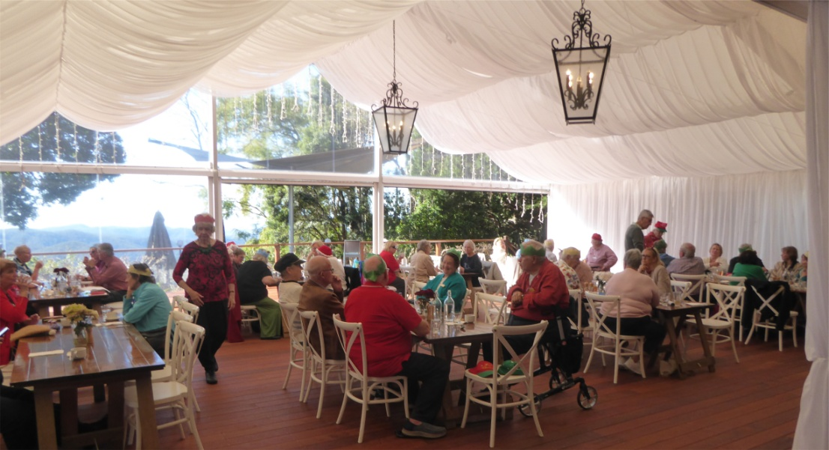Club members enjoying the Christmas in July venue