**REDCLIFFE PENINSULA PROBUS CLUB INC**

Meets on the 4th Tuesday of each month

**July Newsletter 40 Years**

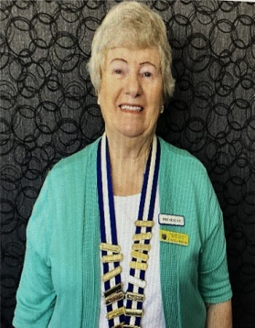Good day to everyone

 . I would like to welcome our new visitors, Graham Arnold, Jenny Muldoon and Diane Smith to the June meeting. You are able to attend three of our meetings before deciding to join.

Congratulations to our newest inductees, Anne and Brian Ray.

Thanks to everyone at the last meeting for their patience when I had to cover the information about the New Constitution and the Standing Resolution. A special thank you to Barbara Smith, our Secretary, who was tasked with preparing and sending out all the information to you at very short notice. The committee met on Thursday and I have decided to include the Standing Resolution pertaining to Refunds and Payment policy as it is important that we are clear on this matter.

“*The Refund and Payment policy refers to the cost of tours conducted by this club. Provided adequate or emergency notice is given of cancellation by a member, there could be a partial or full refund given by the tour director in consultation with committee members. Consideration needs to be given to the fact that the club cannot conduct tours at a loss, as this loss has to be absorbed from club funds. Should there be a surplus of monies, then the surplus will be added to club funds. “*

**5 Minutes of FAME**.

We will start a new segment where a club member may speak for five minutes about some aspect of his/her life. Beryl Curtis has kindly consented to be the first speaker.

**Welfare.**

It is heartening to hear that Neil and Faye Bremner have been able to socialize with Bob and Gloria Blanch in the retirement home. Both are continuing to accept their health prognosis. Joy Turner has returned after being very unwell.

**New Activities**.

I have perused the list of activities that you have suggested and we will act on some of these in the next couple of months. Your suggestions are always welcome.

**Book exchange**.

There are a number of books available at each meeting. These can be borrowed and returned. If you have books that you would like to share, please bring them along to a meeting for exchanging.

**Next meeting.**

Please wear your best shirt, blouse or jumper for some fun to the July meeting. I will offer two small prizes for the best in each gender.

 .

**Birthdays in July**



Maureen Bevins

Alan Davies

Anne Jansen

Patricia Seymour

**Note from Shirley**

**If you would like to attend the morning tea on 8 July, and have not already advised her, will you please contact her no later than Friday 4 July as she needs numbers to make a reservation**.

**Note from Trish**

**Members attending Xmas in July need to rug up warmly and wear closed in shoes. Please also note that Colene McKenzie will look after our Club members on the day. Please report to Colene before boarding the bus. Have a wonderful day!**

**Activities for July**

|  |  |  |  |
| --- | --- | --- | --- |
| **Activity** | **Location** | **Date/Time** | **Contact** |
| Book Club | 5/1 Warde Street Scarborough | 1 July at 2.00pm | Sally Atkins  0451021832 |
| Canasta | Tba | 7, 14, 21, 28 July | Malcolm Gresham  0427497339 |
| Morning tea (see notew) | The Jetty Lounge | 8 July at 10 am | Shirley Megaloconomos 0408772622 |
| Committee Meeting | Lorraine Davis home  65 Centaur St, Kippa Ring | 15 July at 9.30 am | Gayle Mann |
| Club Meeting | Moreton Bay Boat Club | 22 July 9.15 am for 9.30 am start | Gayle Mann |
| Xmas in July  (see note) | St Bernard’s Hotel, Mt Tamborine – cost $81 | 24 July | Trish Seymour  0427240744 |
| **Forward Activites for August** | | | |
| Canasta | Tba | 4, 11, 18, 25 August at 9 am | Malcolm Gresham  0427497339 |
| Book Club | 5/1 Warde Street Scarborough | 5 August at 2.00pm | Sally Atkins  0451021832 |
| Lunch | The Ambassador Hotel, Marine Parade Redcliife | 12 August at 11.30 am | Shirley Megaloconomos 0408772622 |
| Overnight tour | Australian Outback Spectacular & Albert River River Winery | 13 and 14 August  **Note: This tour is fully booked** | Trish Seymour  0427240744 |
| Committee Meeting | Lorraine Davis home  65 Centaur St, Kippa Ring | 19 August at 9.30 am | Gayle Mann |
| Club Meeting | Moreton Bay Boat Club | 26 August 9.15 am for 9.30 am start | Gayle Mann |

Members enjoying lunch at The Brighton Hotel.

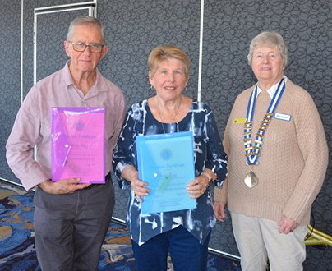

New members, Brian and Ann Ray, with president Gayle Mann after being inducted into our club.

.

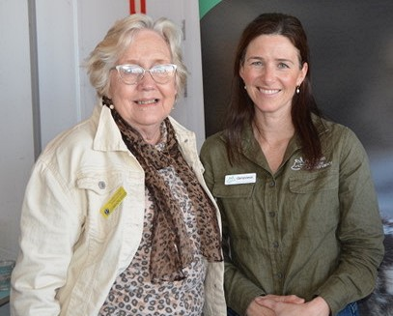

Lorraine Davis with our guest speaker Genevieve who spoke to us on Australian Wildlife Conservancy.