**REDCLIFFE PENINSULA PROBUS CLUB INC**

Meets on the 4th Tuesday of each month

**September Newsletter 40 Years**

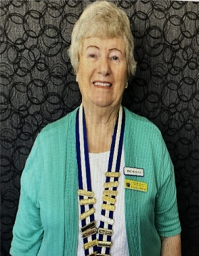Good day to everyone

We will be half way through our Probus year by the end of September. Just to let you know there will be no activities in the month of December. I have listed the important dates for the remaining months as it usually becomes busier as the year closes.

Welcome to our newest visitors, Cecily Corbett and Linda Kirby. You are able to attend three meetings free of our attendance fee. I hope you enjoy our company.

|  |
| --- |
| **Vale Reginald Smith** 24 August 1938 -- 27 August 2025  Reg passed away on Wednesday Morning. He is survived by his wife Dawn and three children. We offer our condolences to the family at this sad time. His funeral will be on Wednesday 10th September at Saint Peter’s the Fisherman Church in Lucinda St Clontarf. |

**Important dates for the remainder of the year**.

!9 September Mystery tour

15 October Probus Day Activity

11 November Committee Morning Tea ( Pelican Park.)

25 November Christmas Party

**Trish Seymour**. Trish has resigned from her position as Tour Director. She joined our club in early 2017. During her time Trish has served as Secretary and Tour Director mainly. She has always been very diligent and reliable in any position. Trish executed her duties in a very thorough manner and provided the club with some excellent tours. We sincerely thank her for volunteering for so long. Now of course we are seeking someone to replace her.

**Positions for Next year**. We are calling for the following positions so that the club can continue in the future. Many thanks to both Paul Hyam who has expressed interest as Treasurer, and Marilyn Hyam for her interest as Membership officer.

* **Positions…**. President, Vice President, Tour Director, Dine outs and PAQ, PSPL representative.
* **Volunteer positions**. Tea persons ….. thank you to Marilyn Davies and Lydia Kolom for offering to do this. We require a back up for the Tyro machine person, Welfare, Hostess, and Baskets. Thanks to Trish Anderson for offering to do this latter position.

**We cannot function as a club if we do not have a President**. Please offer any suggestions with regard to positions. Most of the present committee have served for a number of years and we need some new members.

.

**Christmas Raffles.** Please consider donating items for our raffles which Trish will make into ten baskets for prizes at our Christmas party.

**Guest Speaker**. At the September meeting, Peter Saunders from Retire Invest, will speak on downsizing rules, and the costs of going into retirement villages vs Over 50’s resorts.

I welcome Spring after this cold winter and I hope you all enjoy the next month. Kind regards Gayle

**Birthdays in September**

 Frank Anderson

Bob Blanch

Debra Franklin

Colene McKenzie

Patricia Moritz

Anne Ray

Donald Burgstead

**Activities for September**

|  |  |  |  |
| --- | --- | --- | --- |
| **Activity** | **Location** | **Date/Time** | **Contact** |
| Canasta | Redcliffe Library | 1, 8, 15, 22, 29 September – 9 am | Malcolm Gresham  0427497339 |
| Book Club | 5/1 Warde Street Scarborough | 2 September – 2 pm | Sally Atkins  0451021832 |
| Morning Tea | Sunny’s Sebel Hotel, Margate Pde, Margate, | 9 September – 10 am – **Advise Shirley by 5th if attending** | Shirley Megaloconomos 0408772622 |
| Committee Meeting | 65 Centaur Street Clontarf | 16 September – 9.30 am | Gayle Mann  0434399908 |
| Mystery Tour – cost $68** | TBA | **Friday** 19 September – **Payment needs to be made to Maureeen ASAP** | Trish Seymour  0427240744 |
| Club Meeting | Moreton Bay Boat Club | 23 September – 9.15 for 9.30 am Speaker – Peter Saunders (Retire Invest) | Gayle Mann  0434399908 |

**Forward Notices for October**

|  |  |  |  |
| --- | --- | --- | --- |
| **Activity** | **Location** | **Date/Time** | **Contact** |
| Canasta | Redcliffe Library | 13, 20, 27 October – 9 am | Malcolm Gresham  0427497339 |
| Book Club | 5/1 Warde Street Scarborough | 7 October – 2 pm | Sally Atkins  0451021832 |
| Proibus Day | Visit Da Vinci Exhibition, lunch at Mon Komo | 15 October | Shirley Megaloconomos 0408772622 |
| Committee Meeting | 65 Centaur Street Clontarf | 21 October – 9.30 am | Gayle Mann  0434399908 |
| Club Meeting | Moreton Bay Boat Club | 28 October – 9.15 am for 9.30 am | Gayle Mann  0434399908 |

**Probus trip to the Gold Coast**.

About 30 of us went on this overnight trip: eight from our club and the others from the local probus group we share trips with, and some probus folk from Burpengary. Leaving at the usual time, our first stop was for a boat trip on the canals at the back of Surfers Paradise. We were lucky that the sun came out for this as we glided past the homes of the rich and not quite so rich? Then it was on to the Kurrawa surf club and lunch overlooking the ocean. I had my body board with me and walked down to the beach, however lifeguard advice was that conditions were tricky, so I decided that discretion was the better part of valour. Then it was on to the Dorsett hotel at Broadbeach to check in. Unfortunately there was a bit of a delay as some rooms weren’t ready till 3 pm owing to staff shortages. This is a very large hotel, adjoining the Star Casino and I was surprised no one got completely lost. Our room was spacious with good views of the hinterland, although, it soon came on to rain.

We left for the Outback Spectacular at Oxenford at 6 pm, the journey should have taken about 20 minutes, as indeed it did on our return at 10 pm. But it took nearly an hour to get there. We just had time for group photos wearing our special hats, before it was time to be seated. There were benches in front of each row of seats on which we were served a delicious 3 course meal during the show, together with complimentary drinks. The show was breathtaking in places, with acrobatic displays on horses, cattle mustering and excellent special effects, including a helicopter and a rain storm.

The following morning we enjoyed one of the most extensive buffet breakfasts I have ever seen, before we left for morning tea and lunch at the Albert river winery near Tambourine. I was amazed at how quickly we were out of the hustle and bustle of the Gold Coast and into picturesque countryside. I should mention that our driver, Warren was excellent in giving us a commentary about places and things of interest. The winery was beautifully situated in a quiet valley. It is used extensively as a wedding venue. The area of grape vines was quite small, and unfortunately they had lost the whole crop last year owing to the wet weather at the wrong time. We were guided through some rooms of the historic homestead and the chapel by an unforgettable lady called Yvonne. She is 88 years old and the most sprightly lady of that age I have ever seen. She had an endless fund of stories, many of them very amusing. For instance, she had explained to one group who asked that her funeral would be held in the chapel, then they had asked, would she still be conducting the tours?..

The grand finale of our tour, before a delicious lunch was a demonstration of a kelpie dog herding about a dozen sheep…a demonstration with a difference. This particular dog is rather nervous around sheep and backs off when they approach him. At one point at the end of the round up, in her cowboy hat and boots, Yvonne jumped over 5 barred gate. What a character!

We left about 2 pm, and managed to be back in Redcliffe about 3.30, which was an excellent end to a very memorable trip.

Recorder – Sally Atkins

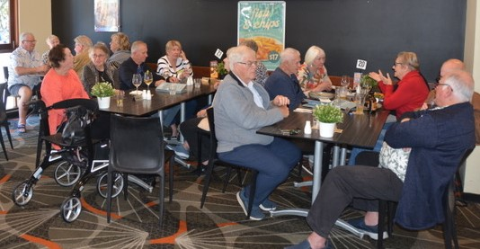Ambassador Lunch

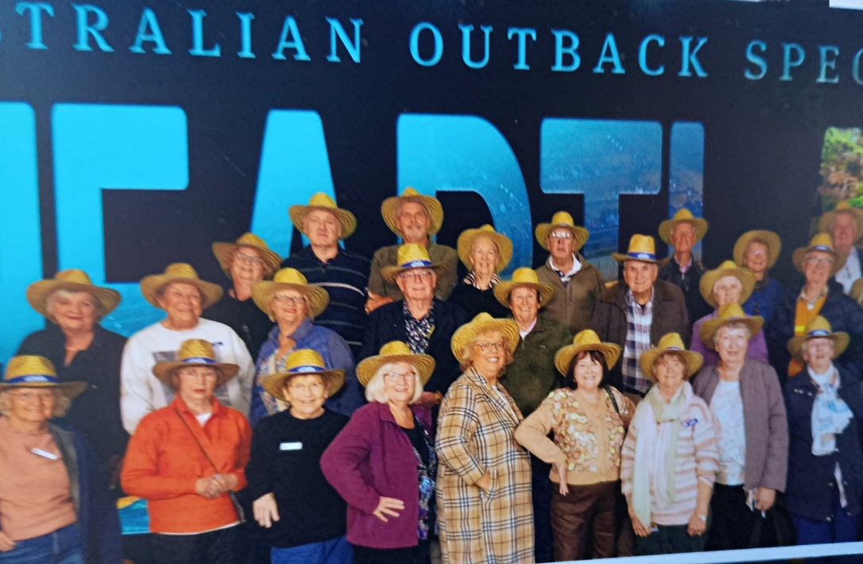

Outback Spectacular Trip

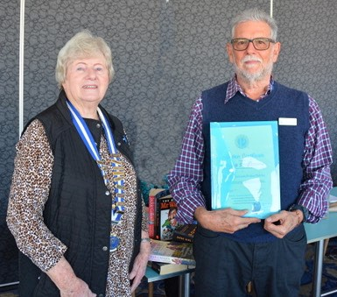

Bruce Shipstone –

inducted August

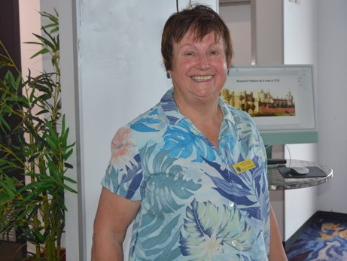

Sally Atkins guest speaker – August meeting speaking on archaeology in England