

REDCLIFFE PENINSULA PROBUS CLUB INC
Meets on the 4th Tuesday of each month
Christmas Newsletter 40 Years

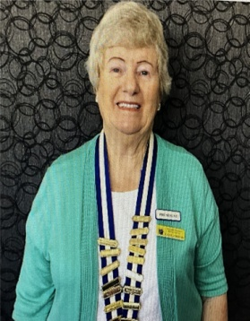
Good day to everyone
For those unable to attend the Christmas lunch I would like to advise that we have been successful in winning a grant to buy a computer and printer for our Dlub. This equipment will be used by our secretary and then successive secretaries.
Activities for January
Activity | Location | Date/Time | Contact
Welcome Back Lunch | Reedcliffe Tavern | Tuesday 13th at 112.30 am | Shirley Megaloconomos 0408772622
Committee Meeting | 65 Centaur Street Clontarf | 20th – 9.30 am | Gayle Mann  0434399908
Club Meeting | Moreton Bay Boat Club | 27th – 9.15am for 9.30am start | Gayle Mann  0434399908
Birthdays in January

Lorraine Parkinson
John Buchanan
Howard Everett
Marilyn Hyam


A full programme for the year will follow but important dates for members are the general meetings held at the Moreton Bay Boat Club and these are:
27 January
24 February
24 March (AGM)
28 April
26 May
23 June
28 July
25 August
22 September
Seasons Greetings
And
A happy new year to all
From your Committee
Redcliffe Peninsula Probus Club
27_October
24 November

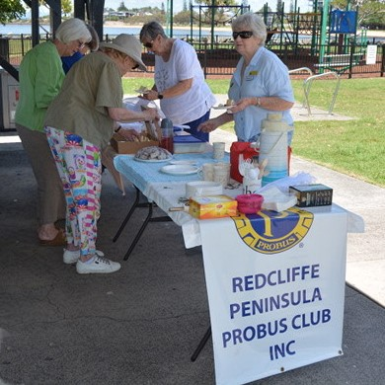
Morning Tea Pictures from Pelican Park
