

REDCLIFFE PENINSULA PROBUS CLUB INC
Meets on the 4th Tuesday of each month
November Newsletter 40 Years

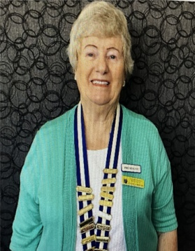
Good day to everyone

This will be the last newsletter for the year. I will provide you with a list of dates of meetings for 2026. This will be handed out at the November Christmas breakup.
We only have two more functions to attend. The first is the Committee morning tea at Pelican Park on the 11th November starting at 10am. Just bring your own drinks and a chair. All the food will be provided. We will be at the southern end of the park.
Our other function is our Christmas breakup starting at 11.30am on Tuesday 25th November at Moreton Bay Boat Club. We will partake of a hot first course and this will be followed by dessert. There will be fun Christmas trivia and raffles. The club will provide wine and soft drink but you can also purchase your own drinks. It is always an enjoyable day. The cost is $40.
Thanks to Shirley Megaloconomos for organizing the brunch at Mon Komo and the visit to the Redcliffe Museum to see the Da Vinci machines. All who went enjoyed the day.
Dine out 2026. Thanks to the three ladies, Marilyn Hyam, Anne Jansen and Dianne East who will coordinate the dine outs next year. These ladies have also offered to do the Christmas baskets next year.
Farwell to Trish and Frank Anderson who are returning to New South Wales . Thanks to Trish for her jokes and for doing the baskets this year. Thanks to all those who helped with this task.
Alan Davies has kindly offered to learn the procedure for Tyro and this will give Denis a break.
A sincere congratulations and thank you to all the people who have stepped up to fill committee vacancies and do the other voluntary jobs. This has been very heartening as it is often difficult to fill positions. It also gives the old committee a well earned rest.
Looking forward to seeing you all at the Christmas function.
Kind regards
Gayle

Birthdays in November and December
November

Ann Ray
Barbara Smith
Flo Wanka
David Harwood
December
Helen Harwood
Ronda Johnson
Gary McKenzie

Activities for November
Activity | Location | Date/Time | Contact
Canasta | Redcliffe Library | 3, 10, 17, 24 November – 9 am | Malcolm Gresham  0427497339
Book Club | 5/1 Warde Street Scarborough | 11 November – 2 pm | Sally Atkins  0451021832
Probus Day | Pelican Park where the new Industry and Co coffee shop is located in the old information Centre | 11 November – 10 am – Committee will provide morning tea – members to bring their tea/coffee and a chair | Shirley Megaloconomos 0408772622
Committee Meeting | 65 Centaur Street Clontarf | 18 November – 9.30 am | Gayle Mann  0434399908
Club Meeting | Moreton Bay Boat Club | This will be a Xmas Break-Up Lunch – 11.30 am – cost $40 | Gayle Mann  0434399908

Activities for January 2026
Activity | Location | Date/Time | Contact
Welcome Back Lunch | Café Diversity, Marine Parade, Redcliffe | 13 January – time to be advised | Shirley Megaloconomos 0408772622
Committee Meeting | 65 Centaur Street Clontarf | 20 January – 9.30 am | Gayle Mann  0434399908
Club Meeting | Moreton Bay Boat Club | 27 January – 9.15 am for 9.30 am | Gayle Mann  0434399908

Many thanks to Frank Anderson for his donation of wine for the Christmas raffles and to Trish Anderson for putting the raffles together. We will miss your jokes and smiling face at our meetings Trish but we wish you both well as you move to your new abode in Terrigal. By the way Trish will you get a Canasta group going in Terrigal – the one you started for our Probus Club is going well. Cheers

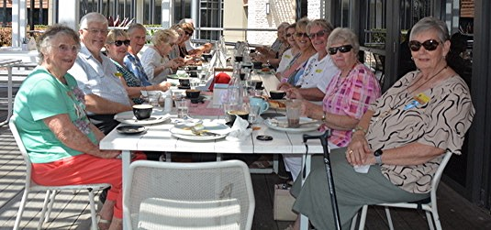
Mon Komo Brunch
October 2025

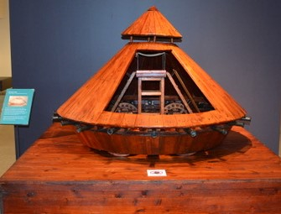
Probus Club visit to Redcliffe Museum
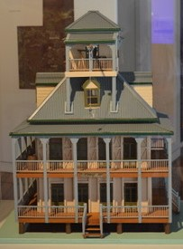
to see the Da Vinci Exhibition - One of the exhibits of a “tank”

Also at the Redcliffe Museum - a model of Victoria House made by our deceased member, Reg Smith

Listed below is an article from the Moreton Daily – September 2019 which published an interview with Reg

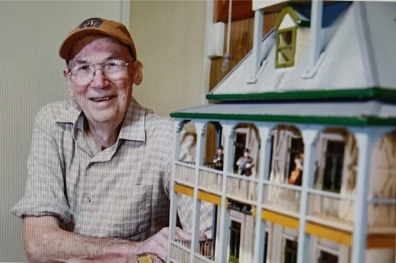
Reg Smith recalls Woody Point’s “Ghost House” from his childhood and later, when he’d drive passed it on his way to work. He even remembers the morning the 80-year-old landmark, also known as the “Wedding Cake House” and the “Lighthouse” burnt down in June 1968. “One day I went passed and it was all ashes. It was a shame. The only thing still standing was the brick chimney” he recalls.

While he never saw its interior, the unusual design and his interest in local history sparked a six-month building project on a much smaller scale. Reg has created a model of the home, actually called Victoria House, using particle board, toothpicks and cardboard. It’s his way of preserving a piece of local history now lost. “I like the old style of it. It’s not something you see – there’s nothing like it in Brisbane. It looks a bit crazy and the last bit looks that it was added on” he says. “ I had a bit of trouble keeping it to scale, because there were no plans for it”. Not deterred, Reg used old photographs to work out the sale – starting with the windows and doors.

He would love to see the model shown in a museum or gallery, so younger generations can appreciate what was once a landmark at Redcliffe.

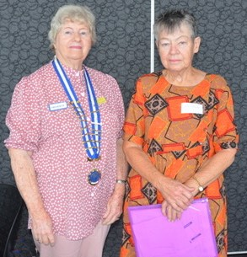
President Gayle with new member, Kim Thomas
inducted at October meeting 2025

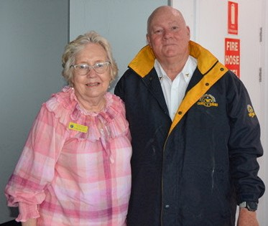
John Hacking from Redcliffe Coast Guard
our speaker at October meeting 2025
together with member Lorraine Davis

