Explore gorgeous autumn gardens, see rare wildlife at the Taronga Western Plains Zoo and discover picturesque towns.

**3 Day | Autumn Dubbo & Mudgee Tour**

Tuesday April 21st – Thursday April 23rd, 2026

$1055 pp – Twin Share

$230 pp Single supplement

8am pick up @ Baulkham Hills Sports Club

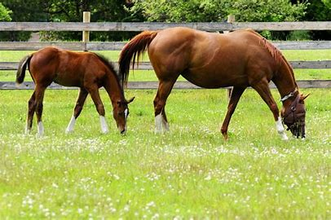

**Day 1: SYDNEY TO DUBBO Tuesday 21st April 2026**

**Welcome to our tour to Country NSW** as we experience the picturesque countrysides of **Dubbo and Mudgee.**   
Our day unfolds amidst the stunning landscapes of **Mayfield Gardens**, an expansive haven celebrated as one of the world's largest privately owned cool climate garden. Nestled within a 5000-acre working farm, the garden’s beginnings were humble in comparison. Since then, it has continued to expand and flourish. We are here to experience the **autumn in the gardens**, where the flaming colours emphasize the season’s remarkable changes in depth, texture and appearance. From here we continue to **Dubbo** to check in to our overnight accommodation.

**Day 2: DUBBO TO MUDGEE Wednesday 22nd April 2026**

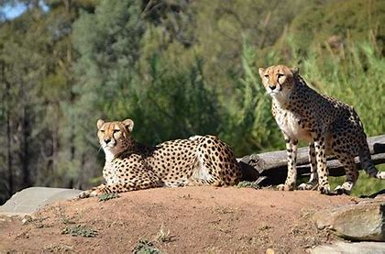We begin our morning at the **Taronga Western Plains Zoo** – home to more than 1100 animals from around the world, many of them endangered species. The zoo is in the unique position to allow many of the animals to roam freely and to be viewed without the visual barriers of fences, bars or glass, instead using a system of dry and water filled moats. A zoo staff member will step onboard our coach and explain the open range layout and some of the behind-the-scenes operations of the Zoo. We depart Dubbo and head for **Mudgee**, an idyllic town nestled within a soft, green valley. Nearby we find **Gooree Park**. One of the most historic and picturesque properties, it has the enviable reputation of being one of the country’s’ leading thoroughbred grounds. Enjoy a guided tour of the stud, lunch and a wine tasting here. We then settle into our lovely accommodation where we enjoy dinner at the onsite restaurant.

**Day 3: MUDGEE TO SYDNEY Thursday 23rd April 2026**

This morning, we are joined by a **local guide** who will share their knowledge about the town before a visit **Mudgee Honey Haven**, one of the towns major tourist attractions. Stocking a wide selection of honeys to taste, trial each variety of honey before you decide on your favourite to purchase. There is also a wide selection of gifts and local produce to browse. Departing Mudgee, we stop at **Ilford Valley Cherry Farm**, nestled in the valley among hundreds of cherry trees. A beautiful area to enjoy our farewell lunch. From here we make our way back to Sydney, arriving home late afternoon.

To register please go to [probusdubboandmudgee.floktu.com](probusmudgeeanddubbo.floktu.com)   
or text Terrie 0410 696 519  
  
$100 deposit due 31 December. Balance due end of February.  
You are welcome to pay a smaller amount each month, if you prefer.