**Providing regular opportunities for retirees and semi‑retirees to keep active**

** *PENRITH SOUTH PROBUS CLUB***

***NEWSLETTER,***

***THURSDAY 21st  AUGUST, 2025.***

**CLUB NO: 9002515**

|  |  |  |  |  |  |  |  |  |  |  |  |  |
| --- | --- | --- | --- | --- | --- | --- | --- | --- | --- | --- | --- | --- |
| |  |  |  | | --- | --- | --- | | **President: Angela 0412 906 040** | **Tours & Social: Diane McL: 0402 535 407** | **Hospitality: Jeanette 4733 4357** | | **V. President: Anne 0408 231 236** | **Newsletter: Ernie: 0411 895 937** | **Welfare: Brian: 0402 535 407** | | **Secretary: Denise 0418 661 223** | **Programmes: Sylvia : 0407 902 996** | **Membership: Genevieve: 0414 841 319** | | **Treasurer: Diane 0438 638 920** | **BANK DETAILS: BSB 032 278 ACC: 413332** | **Public Officer: Alan : 4737 9879** |   ***APOLOGIES FOR NON-ATTENDANCE MUST BE SUBMITTED TO THE SECRETARY PRIOR TO EACH MEETING IN ORDER TO RECEIVE A COPY OF THIS NEWSLETTER.***  ***PLEASE RESPECT MEMBERS AND GUESTS BY TURNING YOUR MOBILE OFF OR SWITCHING IT TO SILENT MODE BEFORE THE MEETING STARTS.***  ***THIS NEWSLETTER IS DELIVERED ELECTRONICALLY TO ALL MEMBERS WITH EMAIL. HARD COPIES ARE AVAILABLE AT EACH MEETING ONLY FOR MEMBERS WITHOUT EMAIL, AND VISITORS.*** |

A clear conscience is a soft pillow – origin unknown.

***STANDING RESOLUTION, No 21.***

21. The Club will adopt a Privacy Policy that outlines how it will collect, hold, use and disclose members’

personal information. (Refer to Probus Club Handbook for further information)

The above was distributed to members as SR 21. before the Committee had worked out how to compile, safeguard,

and use members private information. It is to be deleted and replaced by the following:

(The Ed. apologises for not emailing it out to members as indicated at the last meeting).

***STANDING RESOLUTION No. 21***

It is a condition of membership of the Club that each member completes a membership application form and consents to personal information in the form of their name, address, telephone number, email address, date of birth and next of kin being held by the Club in its Register of Members and such other lists that may be required to be kept, eg, meeting and/or event attendance lists. It is the responsibility of members of the Club Management Committee in general, and the Membership Officer in particular, to ensure that all personal information is securely maintained and only used when

required in connection with Club business and activities. Once a Management Committee Member’s term of office has expired; they are no longer entitled to use any information provided to them while on the Committee, which they must promptly return to the membership officer or, if appropriate, carefully destroy. This applies equally to any member who may have assisted the Management Committee.

***LAST MEETING***

 President Angela opened the meeting, and offered a warm welcome to all present. Apologies were received from Merl Blatch, Gail Conley, Bruce Newham, Vic and Cherryl Faccin, Denice Thomson,

Genivieve and Chris Coburn, Marion Cooley, Norma Fowler, Libby Barr, Joe Baranowski, Wal and

Lauraine Graham. We all missed you and hope to see you again soon. Visitors were Sue Dillon and

Jennifer Halloway. We hope you enjoyed the meeting, and look forward to seeing you again. President Angela then inducted Judy Burling and Halina Ross into membership of the Club. Congratulations to you both. We hope your membership will be long and enjoyable.   
The Guest Speaker, Mike Fogarty, talked about bee keeping, from trapping wild swarms and transferring them to hives, to harvesting the honey from the hives. Looking after bees is not as easy as you would think. It is a time-consuming occupation as can be verified by our own Joe Rzepecki. Mike donated a jar of his honey as a lucky door prize. The lucky door prizes were won by Ellen Rangiawha, Keith Charkes and Hazel Kirkwood.

***AUGUST BIRTHDAYS***



1st – Coleen Brown. 8th – Brian McLean. 8th – Violet Wilson. 9th – Wendy Armstrong. 9th - Loraine Blythe. 9th – Donna Boyd. 14th – Cherryl Faccin. 21st – Frank Baranowski. 28th – Mick Thomson.

28th - Judy Burling.

***DIARY DATES***



**SEPT Tue 9th –** Batemans Bay away trip**. (Be at RSL no later than 6.45 am for 7.00 am departure)**

**Thu 25th –** Manly Day Trip - **Meet at Penrith Station at 7.40 am. Train deps at 7.56 am.**

Ferry dep Cir Quay 10.00 am (Time for Coffee)

**OCT Wed 22nd –** Bass & Flinders River Cruise. Morning tea and lunch on board. **Meet RSL at 8.30 am for**

**8.45 dep.** **(Balance due August meeting)**

**OCT Thu 31st –** Revisit Zig Zag Railway. Pay lunch only - $30 for 2 course lunch. **(Meet RSL 7.45 am for 8.00 am dep)**

**NOV Thu 27th –** Christmas Lunch at Leonay Sports Club. 3 course meal. COST: Members $50.00 after $10 subsidy)

Visitors $60.00.

EXPRESSIONS OF INTEREST: Nan Tien Temple. Biggest Buddhist Temple in Southern Hemisphere. Hour and a half guided tour. Lunch at Woonoona Bulli RSL at own expense Seniors $17 meals. Coach and Tour $40 p/p.

MUDGEE and SURROUNDS and MAYFIELD GARGENS – 6 day & 5 nights. See brochure. ($100 dep due April 2026)

***GUEST SPEAKERS***



**AUGUST:** Caroline Fitzpatrick – Nepean Hospital Trauma Unit.

**SEPT:** One Point Medical Centre – Emma speaking on Dietary needs.

**OCT:** Michael Hiam – Financial matters.



Good example of a Brain Study: If you can read this OUT LOUD you have a strong mind.  And better than that: Alzheimer's is a long, long way down the road before it ever gets anywhere near you!

 7H15 M3554G3 53RV35 7O PR0V3  H0W  0UR  M1ND5 C4N  D0  4M4Z1NG 7H1NG5!  1MPR3551V3  7H1NG5!  1N 7H3 B3G1NN1NG 17  WA5 H4RD  BU7  N0W,  0N 7H15  LIN3  Y0UR M1ND 1S  R34D1NG17  4U70M471C4LLY  W17H0U7  3V3N  7H1NK1NG  4B0U7  17, B3  PROUD!  0NLY   C3R74N P30PL3 C4N  R3AD TH15!

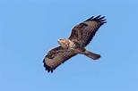THE BUZZARD If you put a buzzard in a pen that is three metres by four metres and is entirely open at the top, the bird in spite of its ability to fly, will be an absolute prisoner. The reason is that a buzzard always begins a flight from the ground with a run of two-and-a half to three metres. Without space to run, as is its habit, it will not even attempt to fly, but will remain a prisoner for life in a small gaol with no top.

***LITHGOW LUNCH***

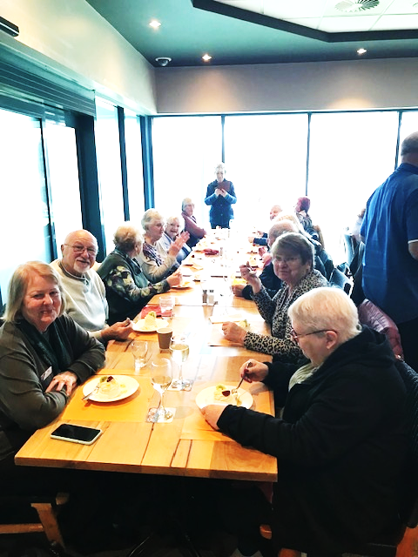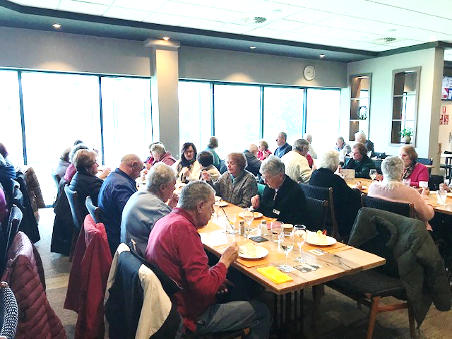



**DISCLAIMER**

**This Newsletter is prepared in editorial format for the information of members. I**t **is written with care and in good faith but does not necessarily reflect Probus policy nor does the Editor accept responsibility for any action taken by any reader because of information contained within.**