Providing regular opportunities for retirees and semi-retirees to keep active



PENRITH SOUTH PROBUS CLUB

NEWSLETTER,

THURSDAY 18th SEPTEMBER, 2025.
CLUB NO: 9002515
President: Angela 0412 906 040 | Tours & Social: Diane Mc 0402 535 407 | Hospitality: Jeanette 4733 4357
V. President: Anne 0408 231 236 | Newsletter: Ernie 0411 895 937 | Welfare: Brian Mc 0402 535 407
Secretary: Denise 0418 661 223 | Programmes: Sylvia 0407 902 996 | Membership: Genevieve 0414 841 319
Treasurer: Diane R 0438 638 920 | BANK DETAILS: BSB 032 278 ACC: 413332 | Public Officer: Alan 4737 9879

APOLOGIES FOR NON-ATTENDANCE MUST BE SUBMITTED TO THE SECRETARY PRIOR TO EACH MEETING IN ORDER TO RECEIVE A COPY OF THIS NEWSLETTER.
PLEASE RESPECT MEMBERS AND GUESTS BY TURNING YOUR MOBILE OFF OR SWITCHING IT TO SILENT MODE BEFORE THE MEETING STARTS.
THIS NEWSLETTER IS DELIVERED ELECTRONICALLY TO ALL MEMBERS WITH EMAIL. HARD COPIES ARE AVAILABLE AT EACH MEETING ONLY FOR MEMBERS WITHOUT EMAIL, AND VISITORS.
Just because you do not take an interest in politics doesn't mean politics won't take an interest in you!
Pericles (430 B.C.)
LAST MEETING

President Angela opened the meeting and issued a warm welcome to all present. Apologies were received from Merle Blatch, Gail Conley, Libby Barr, Kath Feeney, Bob and Carolyn Burns, Rose Kyte, Beverly Wells, Anne Bennett, Brian Corlis, Genia Obrien, Bill and Eileen Swift. We are sorry that you couldn’t be with us and hope you will be back again soon. Visitors were Ernest and Yvonne Jensen, and Geoff and Tanya McAlister. We hope that you enjoyed the meeting and look forward to seeing you again. Finally, the new
Constitution and Standing Resolutions were put to the vote and were passed by members with an absolute majority.
The Guest Speaker, Carolyn Fitzpatric, a member of Rotary since 2017, met with local hospital staff to see what could be done to make children’s hospitalisations more pleasant for them. Her first task was to source companies for funds to
design programmes in children’s wards as they found that children were a lot happier when engaged in activities, and were separated from adult wards. Then came the task of assembling a group of volunteers to work with the children
while they engaged in these activities. They currently have 17 volunteers and are always looking for more. They work two hours a week Monday to Friday. They provide pencils, colouring books, stickers and trauma dolls. She was very appreciative of the dolls presented to her from our members. The Lucky Door prises were won by Sandra Loni and Lakshmi. Congratulations to you both.
SEPTEMBER BIRTHDAYS
6th – Ann Francis. 8th – Diane Squires. 9th – Alison McLaren. 13th – Vivien Parker.
19th – Genivieve Coburn. 21st – Philip Parker. 26th – Janette Charles.

DIARY DATES
SEPT Thurs 25th - Day trip to Manly Meet at Penrith Station at 7.40 am. Train deps at 7.56 am.
Ferry dep Cir Quay 10.00 am (Time for Coffee)
OCT Wed 22nd – Bass & Flinders River Cruise. Morning tea and lunch on board. Meet RSL at 8.30 am
for 8.45 dep.
NOV Fri 7th – Zig Zag Railway. Separate cost for lunch $30.00 due Sept meeting.
NOV Thurs 27th - Christmas Lunch at Leonay Sports Club. COST: Members $50.00. Visitors $60.00.
Expressions of interest due now for visit to Nan Tien Temple
2026
MAR Weds 4th – Tour of Rookwood Cemetery. (See attached PDF)

GUEST SPEAKERS

SEPT: One Point Medical Centre – Emma speaking on Dietary needs.
OCT: Michael Hiam – Financial matters.

HUMOUR
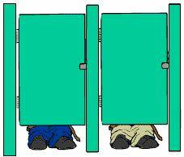
This could happen to you.
I was barely sitting down when I heard a voice from the other toilet saying: 'Hi, how are you?'
I'm not the type to start a conversation in the restroom but I don't know what got into me, so I answered, somewhat embarrassed,
'Doin' just fine!'
And the other person says:
'So what are you up to?'
What kind of question is that? At that point, I'm thinking this is too bizarre so I say:
'Uhhh, I'm like you, just traveling!'
At this point I am just trying to get out as fast as I can when I hear another question.
'Can I come over?'
Ok, this question is just too weird for me but I figured I could just be polite and end the conversation. I tell them
'No..I'm a little busy right now!!!'
Then I hear the person say nervously...
'Listen, I'll have to call you back. There's an idiot in the other toilet who keeps answering all my questions.'
Mobile phones, don't you just love them!
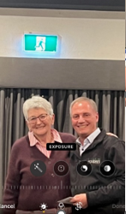
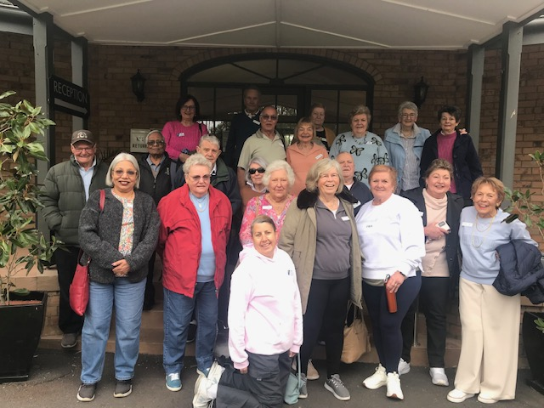
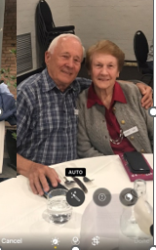
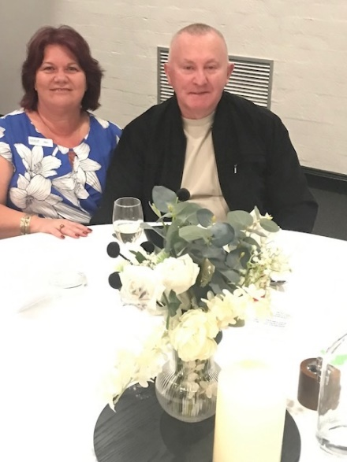
BATEMANS BAY AWAY TRIP


CURFEW - The word "curfew" comes from the French phrase "couvre-feu", which means "cover the fire". It was used to describe the time of blowing out all lamps and candles. It was later adopted into Middle English as “curfeu" which later became the modern "curfew". In the early American colonies, homes had no real fireplaces so a fire was built in the centre of the room. In order to make sure a fire did not get out of control during the night it was required that, by an agreed upon time, all fires would be covered with a clay pot called-a “curfew".

DISCLAIMER
This Newsletter is prepared in editorial format for the information of members. It is written with care and in good faith but does not necessarily reflect Probus policy nor does the Editor accept responsibility for any action taken by any reader because of information contained within.

