Providing regular opportunities for retirees and semi-retirees to keep active



PENRITH SOUTH PROBUS CLUB

NEWSLETTER,

THURSDAY 16th OCTOBER, 2025.
CLUB NO: 9002515
President: Angela 0412 906 040 | Tours & Social: Diane Mc: 0402 535 407 | Hospitality: Jeanette 4733 4357
V. President: Anne 0408 231 236 | Newsletter: Ernie 0411 895 937 | Welfare: Brian Mc: 0402 535 407
Secretary: Denise 0418 661 223 | Programmes: Sylvia 0407 902 996 | Membership: Genevieve : 0414 841 319
Treasurer: Diane 4735 3915 | BANK DETAILS: BSB 032 278 ACC: 413332 | Public Officer: Alan 4737 9879

PLEASE RESPECT MEMBERS AND GUESTS BY TURNING YOUR MOBILE OFF OR SWITCHING IT TO SILENT MODE BEFORE THE MEETING STARTS.
THIS NEWSLETTER IS DELIVERED ELECTRONICALLY TO ALL MEMBERS WITH EMAIL. HARD COPIES ARE AVAILABLE AT EACH MEETING ONLY FOR MEMBERS WITHOUT EMAIL, AND VISITORS.
Waste no time arguing about what a good man should be. Be one – Marcus Aurelius.

LAST MEETING
President Angela opened the meeting and warmly welcomed all present. Apologies were received
from Merle Blatch, Gail Conley, Sylvis Creamer, Bruce Newham, Donna Boyd, Loraine Blythe, Myra
Rogers, Genia O’Brien, Colin & Coralie Richardson. Visitors were Yvonne & Ernst Jensen, Valerie Hayward, Deb Walker, and Sharon Moxham. We hope that you enjoyed being with us and hope you will return again. The Guest Speaker was Emma from One Point Health. Emma, a Dietician, who gave us a great run down on various foods and their nutritional value which seniors should add to their diet. The Lucky Door Prizes were won by Maureen Taylor and Libby Barr.
OCTOBER BIRTHDAYS

1st – Fay Cox. 3rd – Denise Thomson. 5th – Julie Cheetham. 6th - Margaret Maxwell. 20th – Ellen
Rangiawha. 23rd – Genia O’Brien. 26th – Mary Moodley.

DIARY DATES

OCT Wed 22nd – Bass & Flinders Cruise. Meet Penrith RSL at 8.30 am
NOV Fri 7th - Zig Zag Railway. Meet Penrith RSL 7.45 am
Thur – 27th – Christmas Lunch at Leonay Sports Club. $40 and final numbers Oct meeting.
FEB Tue 3rd – Day trip to Nan Tien Temple. Coach & Tour COST: $45 due January meeting.
MAR Weds 4th – Rookwood Cemetery Tour – Includes morning tea and lunch. $40 deposit due
November meeting.
MAR Weds 11th – Seniors Concert
APR TBA
MAY WEDS 5th – Allison Homestead, Saddles Restaurant, Mt. White. Chocolate Factory, Gosford.
THERE WILL BE NO MONTHLY LUNCH IN NOVEMBER
GUEST SPEAKERS

OCT: Mitchell Hyam, Financial Advisor.
NOV: Courtney Edwards, Coach & Holiday Tours.


Alexander the Great was accidentally buried alive. Scientists believe Alexander suffered from a neurological disorder called Guillain-Barré Syndrome. They believe that when he died, he was actually just paralysed and mentally aware!
During World War II, a Great Dane named Juliana was awarded the Blue Cross Medal. She extinguished an incendiary bomb by peeing on it!
The Bloody Mary wasn’t always called Bloody Mary! First, the popular brunch drink was actually called A Bucket Of Blood. After Bucket of Blood, it transitioned to Red Snapper and, finally, settled on Bloody Mary.

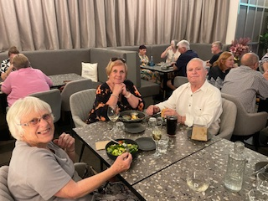

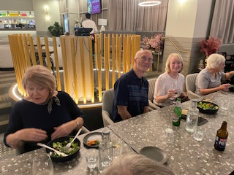
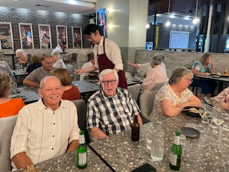
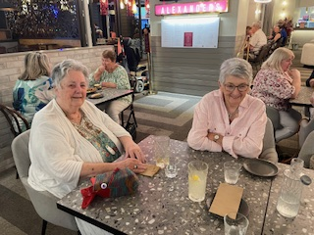
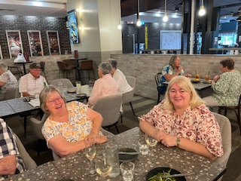
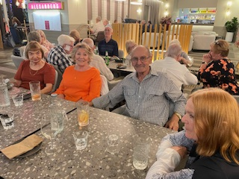
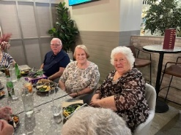
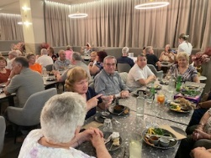
MONTHLY LUNCH AT ALEXANDER’S
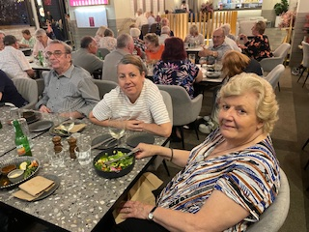
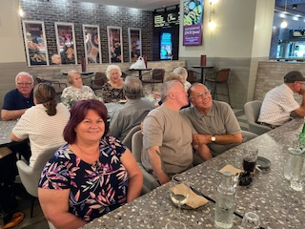
HUMOUR



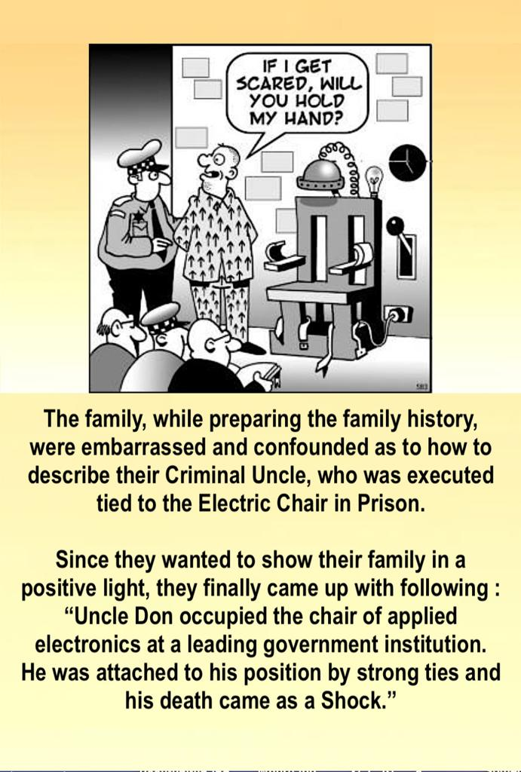


DISCLAIMER
This Newsletter is prepared in editorial format for the information of members. It is written with care and in good faith but does not necessarily reflect Probus policy nor does the Editor accept responsibility for any action taken by any reader because of information contained within.

