Providing regular opportunities for retirees and semi-retirees to keep active



PENRITH SOUTH PROBUS CLUB

NEWSLETTER,

THURSDAY 20th NOVEMBER, 2025.
CLUB NO: 9002515
President: Angela: 0412 906 040 | Tours & Social: Diane Mc: 0402 535 407 | Hospitality: Jeanette : 4733 4357
V. President: Anne: 0408 231 236 | Newsletter: Ernie Campbell: 0411 895 937 | Welfare: Brian Mc: 0402 535 407
Secretary: Denise: 0418 661 223 | Programmes: Sylvia Creamer 0407 902 996 | Membership: Genevieve : 0414 841 319
Treasurer: Diane R: 0438 638 920 | BANK DETAILS: BSB 032 278 ACC: 413332

PLEASE RESPECT MEMBERS AND GUESTS BY TURNING YOUR MOBILE OFF OR SWITCHING IT TO SILENT MODE BEFORE THE MEETING STARTS.
THIS NEWSLETTER IS DELIVERED ELECTRONICALLY TO ALL MEMBERS WITH EMAIL. HARD COPIES ARE AVAILABLE AT EACH MEETING ONLY FOR MEMBERS WITHOUT EMAIL, AND VISITORS.
When a man opens a door for his wife, it’s either a new car or a new wife – Prince Phillip.
LAST MEETING

President Angela opened the meeting and warmly welcomed all present. Apologies were received from Merle Blatch, Ann & Frank Baronowski, Cheryl Speed, Geoffrey & Tanya McAlister, Karen Kessell and Rae Paine. Sorry you were unable to attend and hope you can make our November meeting as it is the last for the year. We welcomed visitors, Debbie Jordan and Stan Baranowski. We hoped you enjoyed the meeting and look forward to seeing you again soon. Guest Speaker, Mitchell Hiam, updated us on the changes to home care packages, Retirement Village requirements, age care. Mitchell said he would email this information to Secretary Denise who will then email it to members.

NOVEMBER & DECEMBER BIRTHDAYS

NOV: 4th – Stewart Yallop. 5th – Julie Cheetham. 6th – Margaret Maxwell. 20th – Ellen Ranhiawha.
23rd – Genia O’Brien. 26th – Mary Moodley. 29th – Chris Coburn.
DEC: 2nd – Tom Cammuso. 2nd Halina Ross. 3rd – Mark Foster. 4th – Tanya McAlister. 12th – Wal
Graham. 13th – Heather Bennett. 13th – Ann Bennett. 16th – Lauraine Graham. 18th – Suzanne Wood.
31st – Libby Barr. Robert Burns.

DIARY DATES
Thur – 27th – Christmas Lunch at Leonay Sports Club.
FEB Tue 3rd – Day trip to Nan Tien Temple. Coach & Tour COST: $45 due January meeting.
MAR Weds 4th – Rookwood Cemetery Tour – Includes morning tea and lunch at Rosehill Bowling Club. $40 deposit due November meeting.
MAR Weds 11th – Seniors Concert.
APR TBA
MAY WEDS 5th – Allison Homestead, Saddles Restaurant, Mt. White. Chocolate Factory, Gosford.
AUG 26th - ANSTO Discovery Tour, Home of Australian Nuclear Science.
OCT: 6th - Pittwater and Palm Beach. Ferry from Pittwater to Palm Beach.

GUEST SPEAKERS

NOV: Courtney Edwards from Coach Holidays.


Australia is known to be as huge as the size of a continent. If you measure the distance from one end to another, it comes out to be equal to the distance between Moscow and London.
Saudi Arabia is famous for camels and its vast deserts for centuries. Do you know from where do most of these camels come from? Yes, you are right! Australia.
It is the second country where women were given the right to vote. It dates back to 1902. It was the time when the
suffragette movement began in the sub-continent and other parts of the world.
DISCLAIMER
This Newsletter is prepared in editorial format for the information of members. It is written with care and in good faith but does not necessarily reflect Probus policy nor does the Editor accept responsibility for any action taken by any reader because of information contained within.

BASS AND FLINDERS CRUISE – ZIG ZAG RAILWAY
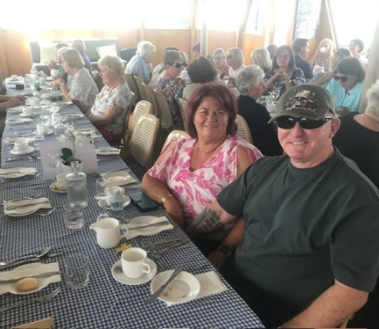
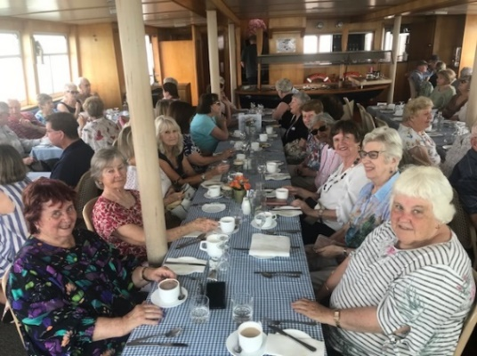
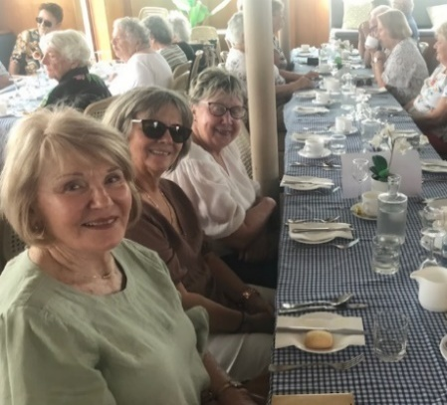

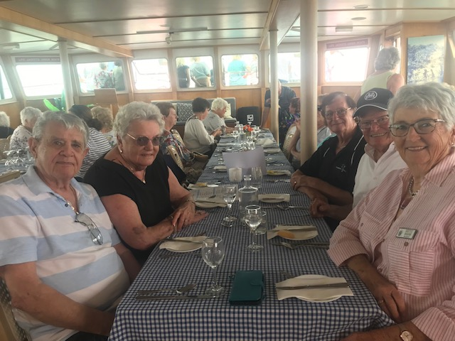
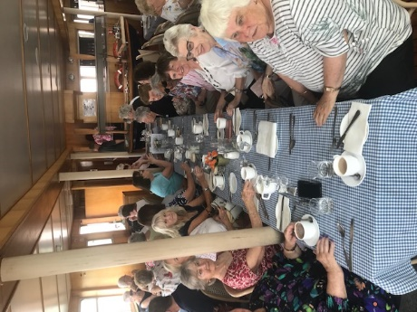
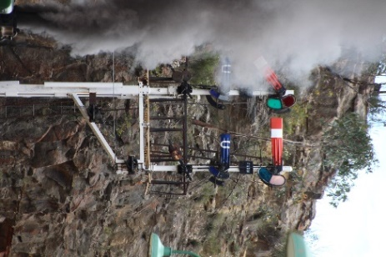


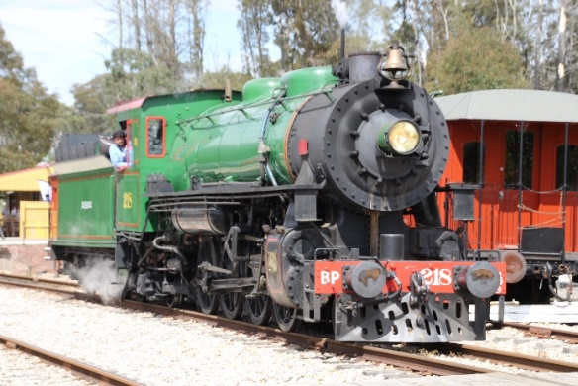
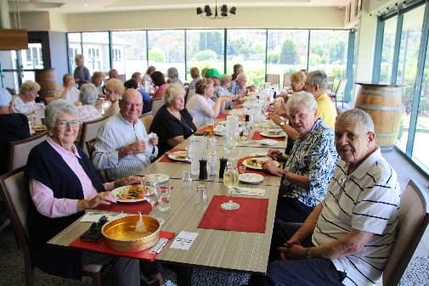
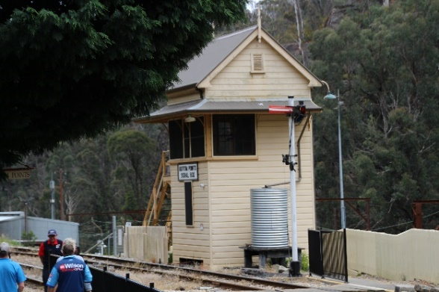

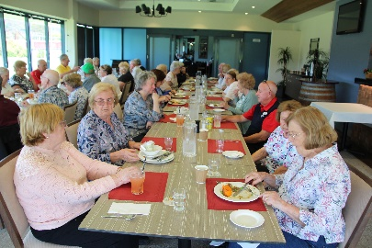
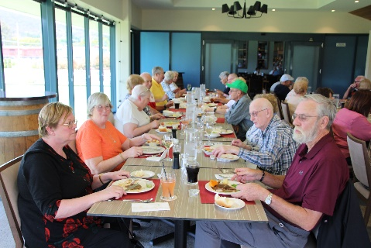
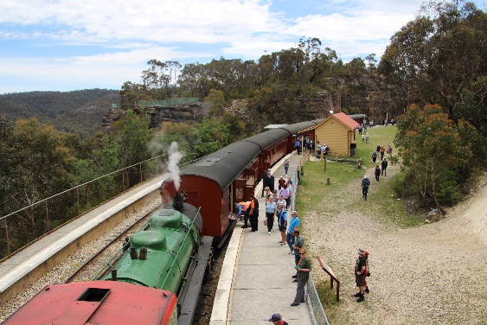

HUMOUR
A smart London lawyer runs a stop sign and gets pulled over by a Glasgow copper. He thinks that he is smarter than the
cop because he is a lawyer from LONDON and is certain that he has a better education than any Jock cop.
He’d prove this to himself and have some fun at the Glasgow cops expense!!
Glasgow cop says, " Licence and registration, please."
London Lawyer says, "What for?"
Glasgow cop says, "Ye didnae come to a complete stop at the stop sign."
London Lawyer says, "I slowed down, and no one was coming."
Glasgow cop says, "Ye still didnae come to a complete stop. Licence and registration, please"
London Lawyer says, "What's the difference?"
Glasgow cop says, "The difference is, ye huvte come to complete stop, that's the law, Licence and registration, please!"
London Lawyer says, "If you can show me the legal difference between slow down and stop, I'll give you my licence
and registration and you give me the ticket. If not, you let me go and don't give me the ticket."
Glasgow cop says, "Sounds fair. Exit your vehicle, sir." The London Lawyer exits his vehicle. The Glasgow cop takes out his baton and starts beating the living crap out of
the lawyer and says, "Dae ye want me to stop, or just slow doon?"

