OCTOBER 2025
It is hard to believe we are on the downhill run to Christmas and the end of 2025. I think someone fast-forwarded the calendar!

ROZ TOWNSEND’S PODCASTS



Roz’s podcasts on Spotify are well worth a listen. These are some of her latest podcasts:

https://podcastle.ai/show/70-roz-OG0ye8Tz/preventing-cognitive-decline-a-chat-with-dr-sarah-stephens-xVdtxpW0
https://podcastle.ai/show/70-roz-OG0ye8Tz/melodies-and-musings-with-jack-mao-ep-38-qpsp7BQd
https://podcastle.ai/show/70-roz-OG0ye8Tz/from-door-to-door-to-global-success-with-janaki-joshi-zlzcKkY0

OCTOBER BIRTHDAYS

October 6 – Eleanor Robertson
October 26 – Sandra Nelson

TOM LEWIS’S LATEST BOOK

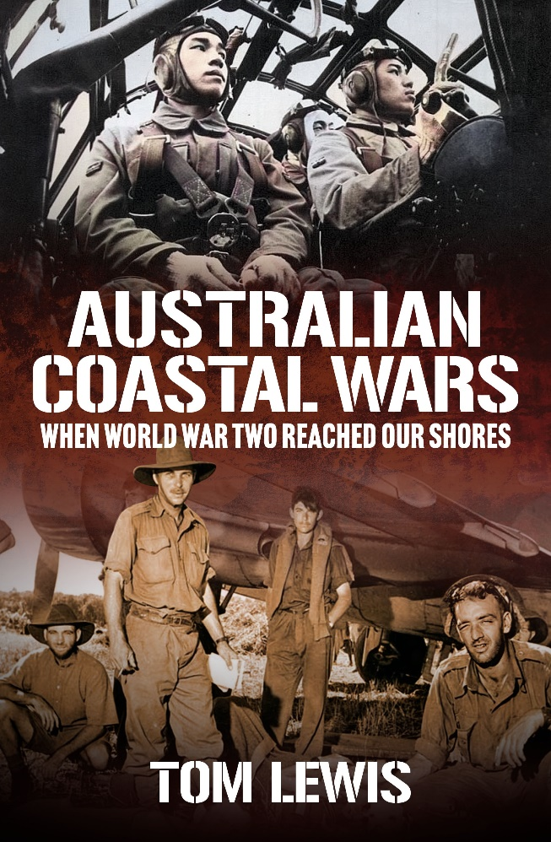
New book describes all WWII enemy action around Australia
Review by Dr Peter Williams
The latest book from military historian Tom Lewis is a weighty work of just over 500 pages. Australia’s Coastal War brings together all the actions around Australia’s coastline through World War II; surface, submarine and air. It is an attempt to show the reader how extensive those battles were, and it succeeds. The action ranges from Darwin to Hobart, from Perth to Townsville, and offshore to encompass mighty battles such as Coral Sea.
The coastal war began with German surface raiders laying mines along the Australian coast and around New Zealand as well. The author acknowledges in his opening pages that he is somewhat wide-ranging in his use of the word “coastal.” He covers incidents all the way to Noumea, and in the closing pages well off the West Australian coast into the Indian Ocean, where in the last month of 1944 and the opening weeks of 1945 a German U-boat was sinking Allied ships.
The early Japanese assaults included the Battle of the Coral Sea, the importance of which Lewis argues is under-recognised by Australians today. Without the USA using Australia as a base for a counteroffensive against the Japanese, the war would have been longer and more difficult.
Even less well known in the country’s consciousness are the many fights off the north-west of the country. The US Navy’s first aircraft carrier was sunk there, although USS Langley was by then relegated to an aircraft transport. The ships of the disintegrating colonial empires – the Dutch and Portuguese, amongst others – were easy pickings for the cruisers and destroyers of the Imperial Japanese Navy.
In amongst battles that sent fighting destroyers like USS Edsall to the bottom were actions such as the gallant defence of HMAS Yarra fighting to defend her convoy. In the Battle of Sunda Strait HMAS Perth fought alongside USS Houston to the end. It is notable how many US actions are described – although in that fight, unlike Captain Rooks of the US Navy, the Australian Navy’s Captain Hec Waller was not rewarded with the equivalent of the Medal of Honor, the Victoria Cross.
Australia’s Coastal War gets into top gear with the wide-ranging aircraft raids, accompanied by extensive submarine attacks at the same time. The Japanese hit northern Australia from Exmouth to Townsville, from January 1942 to August 1944. The huge attack on Darwin, with 188 enemy machines flying the massive raid, gets special attention in the book.
The submarine raids primarily targeted the east coast in two main programs – mid-1942 and mid-1943. One of the author’s previous works, The Secret Submarine, is drawn upon to describe one of the few anti-submarine successes the Australian forces had, sinking a 100 metre Japanese fleet boat, the I-178, with its 86 crew off Newcastle. More widely known was the midget submarine attack on Sydney Harbour, which gets a chapter of its own.
Similarly, not widely known today are the numerous Japanese air raids into northern Australia. This wasn’t because of government secrecy; they were publicised enough in the newspapers of the southern cities, but because they were not often taught as subject matter to the young people in our schools. World War II gets 10 weeks of attention from the national curriculum for Year 10s, but with everything from the Holocaust to the causes and effects of the war to be crammed in, it would seem the fighting along our own shores is still neglected. The book totals 1,889 enemy aircraft flights carried out against Australia – a staggering number, with many of the raids seeing scores of Betty bombers and Zero fighters fighting it out against Kittyhawks and Spitfires. Many of the wrecks of those shot down can still be seen in the Outback today.
Thousands of people are detailed as dying on and around Australia’s coasts in the war. Many of the stories are tragic: from fierce actions such as the loss of the cruiser HMAS Sydney with 645 lives which went down fighting against the raider Kormoran, to death on a quiet beach in South Australia where a mine blew up and killed two men, to the lonely end of a priest captured by an enemy floatplane crew and flown away to be executed.
Lewis catalogues the lesser but still important efforts in the work’s four appendices. He covers the static defences consisting of anti-ship and anti-air guns; the boom nets, anti-submarine loops, and searchlights, and makes the point that such defences were a good deterrent against more intensive attacks – and that their operators were also doing sterling work.
Scores of endnotes provide the comprehensive sources for the work, which includes Japanese and US records. The author gives a lot of credit to the Americans, pointing out that the fighter air defence of the north for most of 1942 was flown by United States Army Air Forces pilots and aircraft, and questions quite rightly Australia’s neglect of its defences.
The work is copiously illustrated, with liberal use of tables listing the total numbers of operations, including fatalities. While the use of a large font is welcome for older readers, the photographs could be lifted in quality by better printing.
Australia’s Coastal War is a welcome addition to the country’s history, and for anyone’s family whose ancestors saw action defending us – or for anyone who wants to understand fully the effects of the war we had here at home, this is an invaluable work.



JERRABOMBERRA PROBUS FACEBOOK GROUP
Join the Facebook Group where you can chat to other members or post items
you think may interest others.
https://www.facebook.com/groups/690245655091944

DIARY DATES


Wednesday, October 1-Friday, October 31
Probus Month
Wednesday, October 15
Jerrabomberra Probus meeting.
Guest speaker: Susannah Fullerton – “Jane Austen”
Wednesday, October 22–Tuesday, November 4
Tuggeranong Probus Club 13-day trip to Tasmania. $6898.00 per person Twin Share (Single Supplement $1352.00)
Contact: Bron Heinrich 0409 895 085
ba.heinrich@bigpond.com
Wednesday, October 22
Jerrabomberra Probus Coffee Club at 10 a.m.
Wednesday, November 5
Jerrabomberra Probus Get-together lunch 12 noon
Wednesday, November 12
Jerrabomberra Garden Club meeting at
Ken and Margaret Stone’s house at 10 a.m.

Wednesday, November 12
PACD Delegates’ meeting 10 a.m. at Southern Cross Club, Jamieson
Wednesday, November 19
Jerrabomberra Probus Meeting
Wednesday, November 22
Jerrabomberra Coffee Club at 10.00 a.m.
Wednesday, December 10
Jerrabomberra Probus Club Christmas Lunch at Embrace Dugout Café, South Jerrabomberra. $30 per person. Friends welcome (No meeting on December 17)
2026
Wednesday, January 21
Jerrabomberra Probus Meeting
Wednesday, March 18–Saturday March 21
Gold Creek Probus Club tour to Blue Mountains including Mayfield Gardens.
$1,585 per person twin share. Enquiries: Heather Homewood robhezz5152@gmail.com2@GMAIL.COM
Wednesday May 15-Wednesday May 22
Greenway Probus Club Murray River Cruise, Victor Harbour, Kangaroo Island.$4,898 per person twin share. Enquiries to Gail 0417 432474
gglacey@hotmail.com Linda 0407 917133 linda.tregonning@bigpond.com
Please contact Eleanor if you require more information on any of these events.

Any ideas for outings can be forwarded to Ann Rau annmrau@hotmail.com

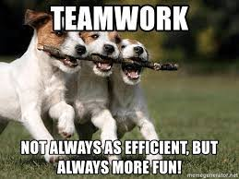

ITEMS FOR THE NEWSLETTER


This is your newsletter, so if you have any news, family celebrations, recipes, book reviews, grandparent brags, photos, deep and meaningful thoughts, whatever, please send them to
eleanor.vqa@gmail.com

WORD PUZZLE
Contributed by Jo Livingston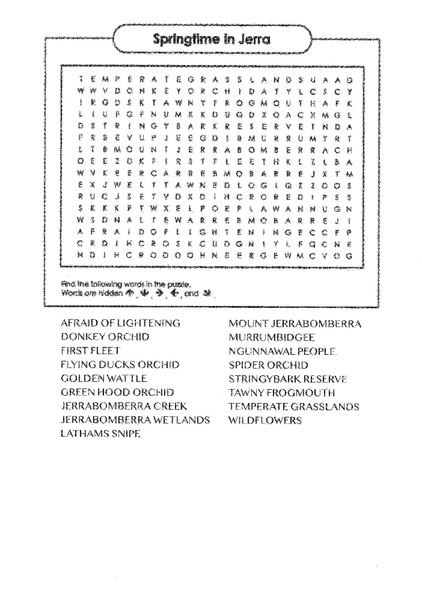


JERRABOMBERRA PROBUS
WEBSITE



President Chris has been spending quite a lot of time to set up our own Jerrabomberra website. This will be
good source of information for our members and a valuable marketing tool to attract new members. Some sections of the website will only be available to our members, and there will be other sections with information that members of the public can access to find out more about our Club such as meeting venue, time, and how to join us.

Chris needs photos showing Club activities (recent and past) so if can help out, please send them to me.

Eleanor
Newsletter Editor

