200th Edition of Pipeline
October 2025
email: probusplentycombined@gmail.com
https://www.probussouthpacific.org/microsites/plentycombined

This publication is solely for the information and interest of members of the Combined Probus Club of Plenty Inc. and adjoining Probus clubs within the district, and is not available to outside bodies for any other purpose. Sponsored by the Rotary Club of Greensborough.

Probus is fun and fellowship in retirement
MANAGEMENT COMMITTEE
President
Veronica Finnerty 0414 812 651
Past President
Maree Ades
Secretary
Chris Helmert 0407 337 725
Treasurer
Lillian Ormandy
Asst Treasurer
Ann Boyce
Data Officer
Gerard Vander
Guest Speaker
Rita Macrae
Social Coordinator
Khaye Davey
Welfare
Joy Ferguson
Minute Secretary
Rick Aitchison
SOCIAL COMMITTEE
Outings
Carole Buckley
Outings
Diane Kent
Events/Dinners
Deirdre Stanley
Trips & Tours and
Morning Melodies
Maree Ades
Theatre
Ann Hume
Cards
Merryl Richardson
Movies
Pamela Mellerick
Chatterbox
Warren Saunders
Mah Jong
Yvonne Tunny
PRESIDENT’S MESSAGE
Welcome to this the 200th issue of our Pipeline newsletter! This month we’re especially pleased to be inducting Bruce Ades as a new member of our Club, and I know you’ll all join me in giving him a very warm welcome.
October always feels like life shifts into fast forward, doesn’t it? The days are getting longer and warmer, and we’re all trying to squeeze in more before the “silly season” arrives. With the footy season behind us, many turn their attention to the fun and colour of the Spring Racing Carnival. Whatever your focus, I hope you also make time to pause, relax, and enjoy the season.
October 1st is recognised as the United Nations Day of Older Persons, and throughout this month, Probus celebrates “Fun and friendship in retirement.” While our Club isn’t holding a specific event in recognition, it’s a great reminder of the many friendships and connections we’ve made through being part of Probus. This year’s theme, “Reinvent your Retirement,” encourages us to connect, celebrate, and perhaps try something new. Why not join in an activity you haven’t tried before, or even consider lending a hand in running the Club? It’s a wonderful way to meet people, discover new interests, and give a little back.
A small reminder—please remember to turn off or silence your phone during meetings.
I look forward to catching up with you all at our October meeting
Warm regards,
Veronica

Meeting Date
October 25th
Greensborough RSL

Guest Speaker
Dr Jenny Gowan Pharmaceutical medications

Chri
Payments Due
October meeting

Balance Lakes Entrance Trip - $900pp twin share
$1,100 single

Christmas Lunch $55pp

Christmas Morning Melodies $25

Pipeline Contributions
Ray Stokes

Celebrating Our 200th Edition of Pipeline

This month marks a special milestone — the 200th edition of our Club’s newsletter! It’s a wonderful opportunity to reflect on all that we’ve achieved since the Club was first conceived by a group of friends in August 2007, registered with Probus South Pacific Limited, and subsequently incorporated under Consumer Affairs Victoria.
Our heartfelt thanks go to those foundation members who joined in 2007 and remain active in our Club today: Thecla Allen, Valerie Everest, Joy Ferguson, Kevin Luckman, Rae Luckman, Margaret Ritchie, Warren Saunders, Lynne Scott, Russell Scott, Di Sizeland, Janet Stokes, Ray Stokes, and Bruce Woodhouse.
A special thank you also to members, past and present, who have contributed articles — and especially to those who have taken on the role of editor — for keeping everyone informed and connected through the years.
Over the past eighteen years, countless friendships have been formed and so many happy memories created — with many more still being made today. Here’s to the fun, friendship, and fellowship that define our Club, and to many more editions of Pipeline to come!

Guest Speaker For October
This month, we are delighted to welcome Dr. Jenny Gowan as our guest speaker. She is a practising pharmacist and an accredited pharmacist who specialises in conducting in-home medication reviews with a particular focus on the safety and quality of medicines. Her extensive expertise and dedication to patient care will undoubtedly make for an insightful presentation. We look forward to her sharing her knowledge with us. Dr. Jenny's profile is extensive and worth reading on google.

Presentation to Andrew Hall and Lola
Speaker for September
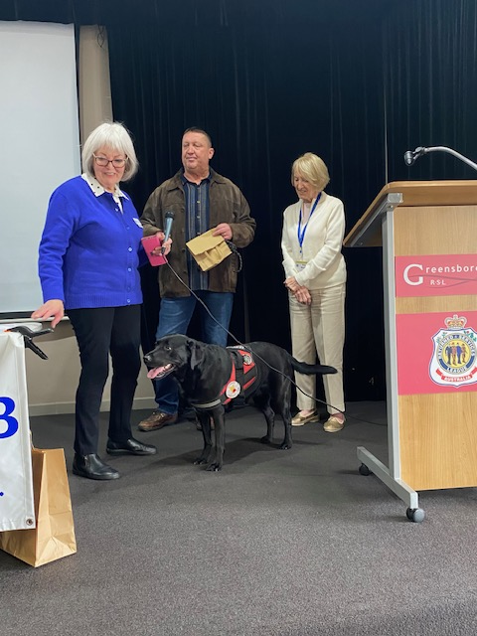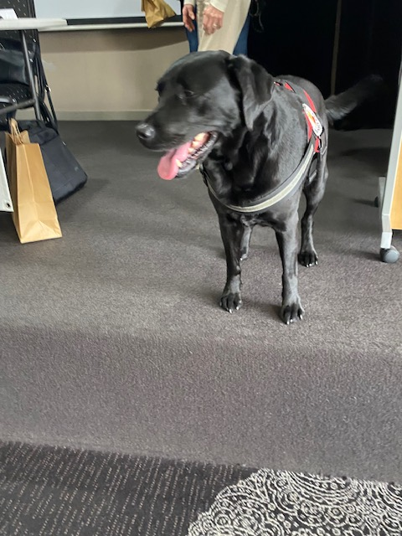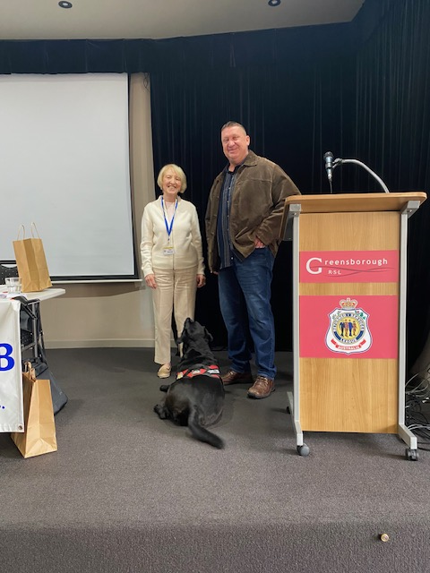

Dinner, Swipers Gully, Research
On Tuesday 7th October, 25 Plenty Probus members enjoyed our annual dinner at Swipers Gully Restaurant at Research. The form 10 and 11 students served the 3-course meal with confidence, indicating their proficiency gained over the time of their tuition. The meal was delicious as always, and all the better for an enormous Full Moon. We thank Patrick, Duncan and staff, for their mentoring skills to provide a unique dining experience.
Khaye

Dandenong Ranges Botanical Park.

On the 2nd October 2025, 39 members ventured onto a coach to Dandenong Ranges Botanical Park in Olinda.
We arrived at Olinda Village and enjoyed a stroll around the shops including “Tea Leaves” the crazy teapot shop. It sold a mega large selection of different tea varieties, also an opportunity for tea lovers to purchase some.
We arrived at the Gardens at 11am. The weather was not in our favour; however, it was an enjoyable time amongst colourful Azaleas and Rhododendrons. Not to mention The Chelsea Garden which was a spectacular sight also.
Lunch followed with a hearty, warming and generous serves of meals at the Pig and Whistle Tavern. Once warmed and refreshed we made our way home.
This outing will be, I’m sure, on so many minds to return to on a sunny day.
Many thanks to Lillian for organizing such a great outing.
Regina

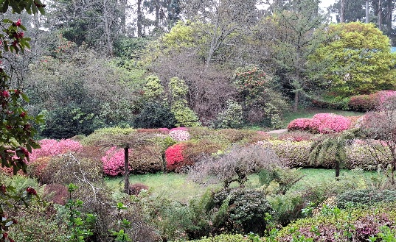
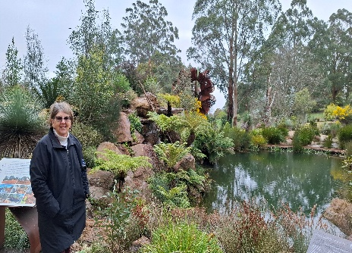


FINANCIAL STATEMENT TO 30th SEPTEMBER 2025

 |  | B/Fwd | INCOME | EXPENSES | BALANCE
GENERAL A/C  033 091 343383 | FEES ETC | 3241.48 | 37.50 | 575.00 | 2703.98
FUNCTION A/C  033 053 533581 | SOCIAL | 2993.90 | 2167.00 | 3876.75 | 1284.15
TRAVEL A/C  033 091 343 391 | TRIPS | 4700.00 | 10100.00 |  | 14800.00
TOTAL |  | 10935.38 | 12304.50 | 4451.75 | $18788.13

AS PER BANK STATEMENTS AS AT 30/9/2025.
FUNCTIONS METHOD OF PAYING: BANK TRANSFERS: Your Name & Event as Reference:
CASH IN AN ENVELOPE WITH NAME, ACTIVITY & AMOUNT ON FRONT. Pay To Organizer
PAYING OVER THE COUNTER AT WESTPAC BANK, DOB as reference example 17121947
LILLIAN ORMANDY : TREASURER. 0439 006 006

Upcoming Events
Please refer to the Activity Calendar for all upcoming events
Christmas Lunch Heidelberg Golf Club Thursday 4 December 12.00pm $55pp.
Reminder!
Our October meeting is the last time for cash payment collection for our Xmas lunch at the Heidelberg Golf Club, on Thursday 4th December $55pp. Please put your name on the Activity list (if you have not already done so) and your money in an envelope provided. Fill out your information on the front, and give it to Me at the morning tea break. This signed envelope will be given back to you at the November meeting, and is a non-refundable amount, please keep it as it is your receipt, you can pass it onto someone else should you be unable to attend (negotiating payment at your discretion). If this does happen, please contact me ….. to give me the name of the person who will attend in your place.
Thank You Khaye

TRAMBOAT CRUISE: JANUARY 29TH 2026 departs 10.15 am

TAKE PUBLIC TRANSPORT: TRAM NO 86

One of the best and most unique ways to take in the Melbourne waterways is with Melbourne Tramboat Scenic Cruises. A different way to cruise in style and comfort! These cruise vessels are quite unique looking, with a fully enclosed lower deck and an open upper deck to take in the scenery as you cruise past ships, docking yards, skyscrapers and parks and gardens. The trip on the boat is for 3.5 hours. Minimum number 30, Max 49.
Next stop Pier 35 Bar & Grill cruise: Departs Victoria Harbour. We cruise downstream along the Yarra River through the Port of Melbourne. We see the large container ships loading and unloading their wares. We travel through the intriguing Port of Melbourne all the way to Williamstown and then back to Pier 35 Bar and Grill for lunch. Morning tea is served on our journey. On arriving at Pier 35 we disembark for lunch and our guests can simply enjoy the scenery whilst having a hot meal. A one course hot lunch with herbed bread. Duration approx.: 3.5 hours Cost $62.00 per person, Includes lunch.

Tramboat departs: Ferry terminal 130 on Harbour Esplanade Docklands directly opposite Marvel Stadium In front of the COW IN THE TREE. (Transport Free Zones)
Trams: No 86 from the corner of Bourke and Spencer Street (or board at Flinders Street)
Trains: Closest is Southern Cross Station
Contact Lillian Ormandy for Further Information ……

THE PREVIOUS FORM WAS AN EXPRESSION OF INTEREST FORM, NOW A DATE, TIME AND COST HAS BEEN WORKED OUT I NEED A NEW FORM. MONEY IS NEEDED BY THE NOVEMBER MEETING.
Money to Ann Boyce my assistant treasurer or transferred to our Function Bank account
bsb 033 053 account number 533 581. Cash paid into our bank account must have reference DOB
PLEASE PUT YOUR NAME ON ATTACHED PROBUS ACTIVITY FORM

Good Wishes to Our Members
Celebrating November Birthdays
Maree Ades Sylvia Barry
Valerie Everest Sue Leahy
Erin Southee Deirdre Stanley
Barbara Wilson


“To our members who are not in the best of health or are recovering from surgery, we send our heartfelt thoughts and best wishes for a swift recovery and brighter days ahead.”


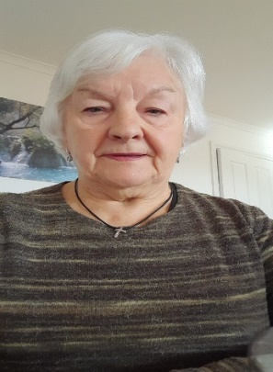
GETTING TO KNOW YOU

NAME………Regina Di Pasquale

QUESTIONS | ANSWER (all optional)
When did you join Plenty Probus and why? | 2014 Meeting new people
Which Probus Activities most interest you? | Trips, Theatre, Morning Melodies
Where were you born? | Italy
Who was your childhood hero or idol? | Elvis
What did you want to be when you grew up? | Hairdresser
Are you a traveler? | Yes
Where is your favourite place to spend leisure time? | In the garden & walking
Who would you like to be marooned on an island with? | My best friend
Who do you think would make interesting dinner guests? | Mother Teresa, Cliff Richard
What is your favourite food? | Seafood
What is your signature dish? | Lasagna
Your favourite Band, singer or actor (past or present)? | Frankie Valley, Sidney Portier
Which superhero, cartoon or comic strip character most fits your personality
Hobbies | Sewing, Crochet & Gardening

SOCIAL ACTIVITIES CALENDAR

DAY | DATE | ACTIVITY | ORGANISER | LOCATION | COMMENT
Tues | Oct 21st | Chatterbox | Warren | Manx Café Montmorency | 10.30 am
Mon | Oct 27th | Movies and Lunch | Pam | Hoyts G’boro.
Wed | Oct 29th | Dolly Parton | Ann Hume | Comedy Theatre | 2.00 pm $91pp
Mon | Nov 3,10, 17,24 | Mah Jong | Khaye/Yvonne | Eltham
Tues | Nov 4th-8th | Lakes Entrance Trip | Maree | 5 days 4 nights | Balance due Oct mtg. $900pp twin $1,100 single
Wed | Nov 5th | Chatterbox | Warren | Urban Grooves | 10.30 am
Thurs | Nov 6th | Cards | Merryl | 8 Armstrong St Greensborough | 7.00 pm
Tues | Nov 18th | Chatterbox | Warren | Mains Eltham | 10.30 am
Tues | Nov 25th | Morning Tea | Khaye | Melissa’s Templestowe | 10.00 am
Mon | Dec 1,8,15, 22, 29 | Mah Jong | Khaye/Yvonne | Eltham | 10.00 am
Mon | Dec 1st | Movies and Lunch | Pam | Hoyts G’boro | TBA
Tues | Dec 2nd | Chatterbox | Warren | Miss Pryor Eltham | 10.30 am
Thurs | Dec 4th | Christmas Lunch  2 Course | Khaye | Heidelberg Golf Club | 12.00 pm  $55.00pp Payment due Oct mtg.
Mon | Dec 8th | Morning Melodies & Lunch | Maree | Arts Centre St Kilda Rd concert. Lunch Young & Jacksons | $25 due Oct mtg. Pay on day lunch at Y&J - $40
Tues | Dec 16th | Chatterbox | Warren | Urban Grooves Greensborough | 10.30 am
2026
Mon | Jan 5, 12, 19, 26 | Mah Jong | Khaye/Yvonne | Eltham
Tues | Jan 6th | Chatterbox | Warren | TBA
Wed | Jan 14th` | Dinner | Yvonne | TBA
Tues | Jan 20th | Chatterbox | Warren | TBA
Mon | Jan 26th | Australia Day picnic | Joy | TBA
Thurs | 29th | Tram boat Cruise incl lunch | Lillian | Docklands/William-stow | $62 pp due Nov mtg
Please register your interest in attending on the Activities Sheets.
Envelopes will be on the Activities Table for your use for all Outings and Activities going forward.

