

**Christmas Lunch**

**AND END-OF-YEAR GATHERING**

**Monday 8th December 2025**

**11.30am to 3.30pm**

**at Pennant Hills Golf Club**

Cnr Copeland and Burns Rd, Beecroft

Delicious 2 course alternate servings – Main and Dessert

$90 per member (subsidised by our Club) or $95 per non-member or visitor - includes drink on arrival and a couple of bottles of wine on tables

Lucky door prizes

A 20-minute bus trip from Castle Hill (651 bus) or lots of parking at the club

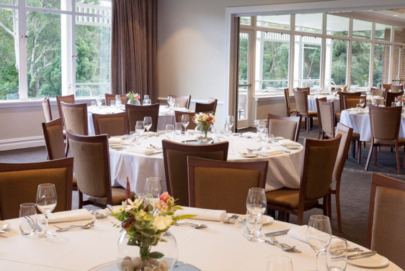EFT 45999 payment by 8th November, 2025