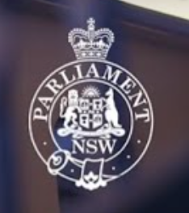
TOUR OF PARLIAMENT HOUSE FOLLOWED BY HIGH TEA
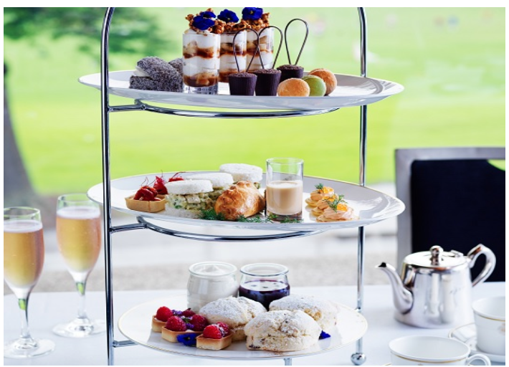
Friday 16 January 2026
10.30am – Tour
12.00 noon – Traditional High Tea in a private dining room
You will make your own way there by public transport
Close to Martin Place Metro stop

Cost of tour is free but High Tea is $70 per person payable to 46038 by 5/1/26
After paying, please notify the Treasurer and Di Carroll

