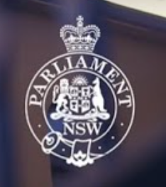
2ND TOUR OF PARLIAMENT HOUSE FOLLOWED BY
HIGH TEA
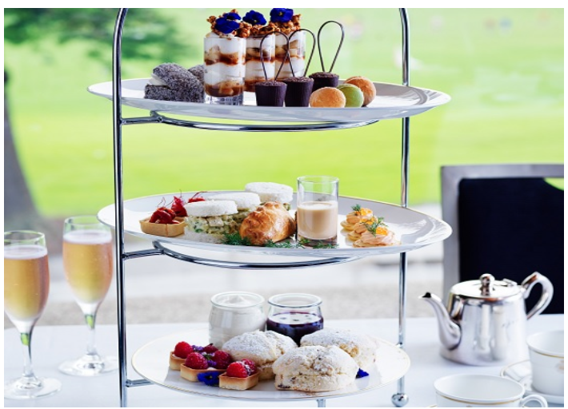
Friday 20th February 2026
11.30am – Tour
12.30 noon – Traditional High Tea
You will make your own way there by public transport
Close to Martin Place Metro stop

Cost of tour is free but High Tea is $70 per person payable to 46073 by 9/2/26
After paying, please notify the Treasurer and Di Carroll

